**GROUP NAME:** Heisenberg

**CLIENT NAME:** Los Pollos Hermanos [Synthetic Client]

**TEAM MEMBERS: [sorted alphabetically by last name]:**

· Adikkesavelu, Aasvitha

· Gade, Rakshit

· Padimiti, Phanidhiraj

· Ramasubbu, Harini

· Thondepu, Manish Kumar

· Vanguru, Karthikeya Reddy

**TABLE OF CONTENTS:**

**Chapter-1 :Requirement Analysis--------------------------------------------------------------------------------** 3

**Chapter-2: Conceptual Schema-------------------------------------------------------------------**----------------5

**Chapter-3:Relational Schema ------------------------------------------------------------------------------------**13

**Chapter-4:SQL Queries ----------------------------------------------------------------------------**---------------27

**Chapter-5:Triggers and Procedures -------------------------------------------------------------**---------------72

**Chapter-6: User Interface ----------------------------------------------------------------------------------------** 78

**Chapter-7: Implementation plan-------------------------------------------------------------------**--------------87

**Appendix A ---------------------------------------------------------------------------------------------**-------------89

**Reference -----------------------------------------------------------------------------------------------**-------------89

# 

# Chapter 1:

## Business Requirements:

**Client:** Los Pollos Hermanos

**Requirement Analysis:**

|  |  |
| --- | --- |
| **Industry** | Fast food restaurants (chain) |
| **User** | Branch manager |
| **Platform** | Web |
| **User goal** | To have a secured platform to view and manage operations, suppliers, performance, payments, and employees of a branch |
| **Performance metrics** | * Number of orders placed * Number of menu items managed or added * Number of promotions managed or added * Number of reservations managed or added * Number of time employees managed or added * Number of salary analysis requests * Number of best customer analysis requests * Number of delivery summary analysis requests   (as per specified timeframe) |

**Requirements:**

To have a platform for a branch manager to perform Operational Management, Performance Analysis, Financial Oversight, Employee Management, and Supplier Management

When a customer places an order, we collect the name(first and last), phone number, emailID, and a customerID which is allocated in a sequence order. The order details are stored along with the date and amount; additionally an ID is assigned to the order. Along with the order details, the payment details such as payment amount, status of payment, date of payment, and payment method are stored. We also must record the feedback that a customer can give for each order they place with the details such as the rating that they provide, comments, and date. For each order, a customer can give multiple feedback.

A customer can be a part of a loyalty program which is not mandatory, and every customer can be enrolled to a single loyalty program at a single time. For each membership, the membership ID, start date, end date, and description are stored. Customers can also make reservations which store the details such as the reservation ID, party size, contact number, reservation time, and preferences.

There are multiple branches of the food chain and hence details of each of the branches or location such as the phone numbers, branch name, and address are stored. Each branch/location is allocated with a unique ID.

Each event can be hosted at the locations and for each event the event ID, event name, date, and description are stored. Each location is also mapped to a warehouse and the details of the warehouse including the warehouse ID, address, capacity, and phone number of the warehouse are stored.

Some of the orders are placed online for which delivery details such as the delivery personal name, delivery address, date, status, and time of delivery are stored and these are attributed to each delivery with a unique ID. To deliver the orders there are certain delivery partners who facilitate the delivery and the details of the delivery partners are stored which includes the primary phone number, payment method, address of the delivery partner, delivery mode, email address which can be multiple, and the delivery partner name.

The food chain has a common menu and the details of the menu items are stored including the name of the menu item, price, description, and each of the menu items is attributed to a unique ID. Menu items are made of ingredients and details such as ingredient ID, name, price per unit, and unit of measurement for each ingredient is stored. Each order contains a list of menu items including the name of the menu item and quantity. Each menu item belongs to a specific category and the details of each category are the name of the category, description, and number of items are stored. Sometimes promotions are applied to the orders and the promotion details such as name of the promotion, discount applicable with the promotion, description, start date, and end date are stored along with the unique ID for each promotion

There are suppliers who supply the ingredients and each supplier is stored with the details such as name, address, contact number, and product category. All the ingredients are stored in the warehouse.

# 

# Chapter 2:

## ER Diagram:

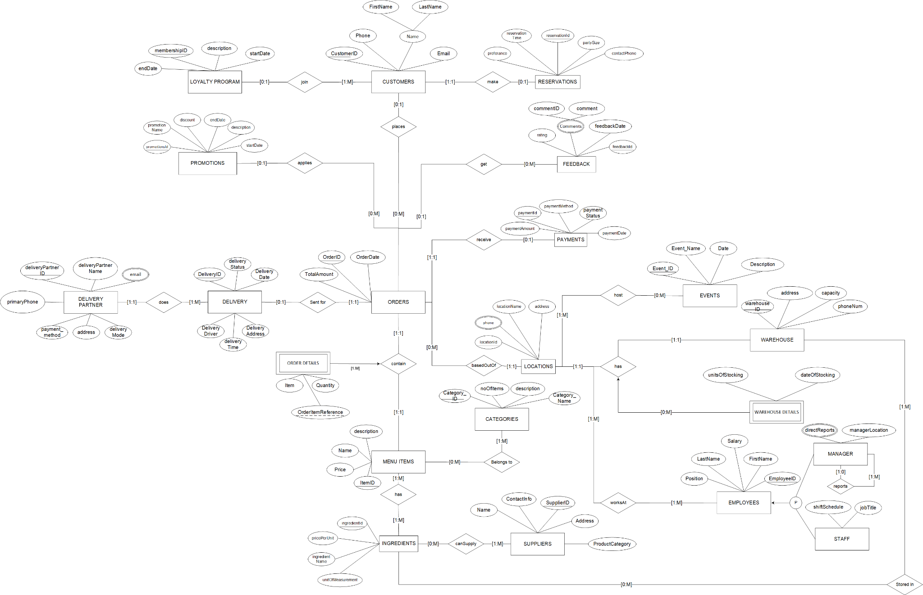

## Data Dictionary:

## The below table gives us the details of data that we used to construct our initial ER diagram.

|  |  |  |  |
| --- | --- | --- | --- |
| **Schema Construct** | **Construct Meaning** | **Data Type** | **Structure and/or Constraints** |
| CUSTOMERS | Entity class to store information on Customers |  |  |
| CustomerID | Unique identifier for each customer | NUMBER | Primary ID |
| Name | Composite Attribute. Contains FirstName and LastName | VARCHAR2(100 BYTE) |  |
| Email | The email address of the customer | VARCHAR2(100 BYTE) |  |
| Phone | The phone number of the customer for contact | VARCHAR2(20 BYTE) |  |
| LOYALTY_PROGRAM | Entity class, to store information on Loyalty Program |  |  |
| MembershipID | Unique identifier for each loyalty program | NUMBER | Primary ID |
| Description | A brief description of the loyalty program | VARCHAR2(255 BYTE) |  |
| StartDate | The date when the loyalty program starts or was launched | DATE |  |
| EndDate | The date when the loyalty program ends or expires | DATE |  |
| RESERVATIONS | Entity class, to store information on Reservations |  |  |
| ReservationID | Unique identifier for each Reservation | NUMBER |  |
| ReservationTime | Time of the reservation | TIMESTAMP(6) |  |
| PartySize | Number of people in reservation | NUMBER |  |
| Preference | Preference of the table | VARCHAR2(255 BYTE) |  |
| ContactPhone | Contact information | VARCHAR(15 BYTE) |  |
| PROMOTIONS | Entity class, to store information on promotions |  |  |
| PromotionsID | Unique identifier for each Promotion | NUMBER | Primary ID |
| PromotionName | Title of promotion | VARCHAR2(100 BYTE) |  |
| Description | Brief description of promotion | VARCHAR2(255 BYTE) |  |
| StartDate | Start date of promotion | DATE |  |
| EndDate | End date of promotion | DATE |  |
| Discount | Amount of Discount | NUMBER |  |
| FEEDBACK | Entity class, to store information on customer feedback |  |  |
| FeedbackID | Identifier | NUMBER | Primary ID |
| FeedbackDate | Date and time of feedback | DATE |  |
| Rating | Scale of rating | NUMBER |  |
| Comments | Multivalued composite attribute contains CommentID, Comment | VARCHAR2(255 BYTE) |  |
| DELIVERY_PARTNER | Entity class, to store information on Delivery partner |  |  |
| DeliveryPartnerID | Identifier | NUMBER | Primary ID |
| DeliveryPartnerName | Name of the Delivery Partner | VARCHAR2(100 BYTE) |  |
| Email | Email address of the delivery partner (Multivalued attribute) | VARCHAR2(255 BYTE) |  |
| DeliveryMode | Type of Delivery (Express/ Normal) | VARCHAR2(50 BYTE) |  |
| Address | Address of the delivery partner | VARCHAR2(255 BYTE) |  |
| PrimaryPhone | Credit Limit of the delivery Partner | VARCHAR2(15 BYTE) |  |
| PaymentMethod | The preferred payment method for the delivery parter | VARCHAR2(50 BYTE) |  |
| DELIVERY | Entity class to store information on Delivery |  |  |
| DeliveryID | Unique identifier for each delivery | NUMBER | Primary ID |
| DeliveryDate | The date and time when the delivery was scheduled or made | DATE |  |
| DeliveryAddress | The address where the delivery is intended to be sent | VARCHAR2(255 BYTE) |  |
| DeliveryStatus | The status of the delivery | VARCHAR2(50 BYTE) |  |
| DeliveryDriver | The name or ID of the delivery driver responsible for the delivery | VARCHAR2(100 BYTE) |  |
| DeliveryTime | Time at which order will be delivered | TIMESTAMP(6) |  |
| ORDERS | Entity class to store information on Order Details |  |  |
| OrderID | Unique identifier for each order | NUMBER | Primary ID |
| OrderDate | The date and time when the order was placed | DATE |  |
| TotalAmount | The total cost of the order, including all menu items | NUMBER |  |
| PAYMENTS | Entity class to store information on Payment |  |  |
| Payment ID | Unique identifier for each payment | NUMBER | Primary ID |
| PaymentMethod | The payment method used | VARCHAR2(50 BYTE) |  |
| PaymentDate | The date and time when the payment was made | DATE |  |
| PaymentAmount | The amount of the payment made for the order | NUMBER |  |
| PaymentStatus | Status of the payment | VARCHAR2(50 BYTE) |  |
| ORDER_DETAILS | Weak Entity class to store information on Order Details |  |  |
| OrderItemReference | Partial identifier | NUMBER |  |
| Item | Item Name that is ordered | VARCHAR2(100 BYTE) |  |
| Quantity | Number of quantity ordered | NUMBER |  |
| LOCATIONS | Entity class to store information on Location |  |  |
| LocationID | Unique identifier for each location | NUMBER | Primary ID |
| Location Name | The name of the location | VARCHAR2(100 BYTE) |  |
| Address | The address of the location, including street address, city, state, and postal code | VARCHAR2(255 BYTE) |  |
| Phone | Multivalued attribute | VARCHAR2(20) |  |
| EVENTS | Entity class, to store information on Events |  |  |
| EventID | Unique identifier for each Event | NUMBER | Primary ID |
| EventName | Name of the Event | VARCHAR2(100 BYTE) |  |
| Date | Date and Time of the Event | DATE |  |
| Description | Details of the Event | VARCHAR2(255 BYTE) |  |
| WAREHOUSE | Entity class, to store information on Warehouse |  |  |
| WarehouseID | Unique identifier for each Warehouse | NUMBER | Primary ID |
| Address | Address of the warehouse | VARCHAR2(255 BYTE) |  |
| Capacity | Capacity of the warehouse | NUMBER |  |
| PhoneNum | Contact phone number of the warehouse | VARCHAR2(15 BYTE) |  |
| WAREHOUSE_DETAILS | Weak Entity class to store information on Warehouse Details |  |  |
| UnitsOfStocking | Number of units stocked | NUMBER |  |
| DateOfStocking | When the item is stocked in warehouse | DATE |  |
| MENU_ITEMS | Entity class to store information on Menu Item |  |  |
| ItemId | Unique identifier for each menu item | NUMBER | Primary ID |
| Name | The name or title of the menu item | VARCHAR2(100 BYTE) |  |
| Price | The price of the menu item | NUMBER |  |
| Description | Decription of the item | VARCHAR2(255 BYTE) |  |
| CATEGORIES | Entity class, to store information on Category |  |  |
| CategoryID | Unique identifier for each category | NUMBER | Primary ID |
| CategoryName | Name of the Category | VARCHAR2(50 BYTE) |  |
| NoOfItems | Number of items in the category | NUMBER |  |
| Description | Description of the category | VARCHAR2(255 BYTE) |  |
| INGREDIENTS | Entity class to store information on Ingredients |  |  |
| IngredientID | Unique identifier for each ingredient | NUMBER | Primary ID |
| Ingredient Name | The name of the ingredient | VARCHAR2(100 BYTE) |  |
| PricePerUnit | The price of the ingredient per unit of measurement | NUMBER |  |
| UnitOfMeasurement | The unit of measurement for the ingredient | VARCHAR2(50 BYTE) |  |
| SUPPLIERS | Entity class to store information on Supplier |  |  |
| SupplierID | Unique identifier for each supplier | NUMBER | Primary ID |
| Name | The name or business name of the supplier | VARCHAR2(100 BYTE) |  |
| ContactInfo | Contact information for the supplier, which may include an email address or phone number | VARCHAR2(100 BYTE) |  |
| Address | The address where the supplier is located or can be reached | VARCHAR2(255 BYTE) |  |
| ProductCategory | The category of products or ingredients supplied by the vendor | VARCHAR2(50 BYTE) |  |
| EMPLOYEES | Entity class to store information on Employee |  |  |
| EmployeeID | Unique identifier for each employee | NUMBER | Primary ID |
| FirstName | The first name of the employee | VARCHAR2(50 BYTE) |  |
| LastName | The last name of the employee | VARCHAR2(50 BYTE) |  |
| Position | The job position or role of the employee within the organization | VARCHAR2(50 BYTE) |  |
| Salary | The salary or hourly wage of the employee | NUMBER |  |
| MANAGER | Sub class to Employees. Stores information on Managers |  |  |
| ManagerLocation | Store Manager Location | VARCHAR2(50 BYTE) |  |
| DirectReportees | Number of employees reporting to manager | NUMBER |  |
| STAFF | Sub class to Employees. Stores information on Staff |  |  |
| ShiftSchedule | Work schedule of staff employees | VARCHAR2(50 BYTE) |  |

# 

# 

# Chapter-3

## Relational Design:

**Normalization**

**BELONG_TO**(ItemID, CategoryID)

Foreign Key(ItemID) references MENUITEMS

Foreign Key(CategoryID) references CATEGORIES

**CANSUPPLY**(ingredientID, SupplierID)

Foreign Key(ingredientID) references INGREDIENTS

Foreign Key(SupplierID) references SUPPLIERS

**CATEGORIES**(CategoryID, description, noOfItems, CategoryName)

**CUSTOMERS**(CustomerID, FirstName, LastName, Phone, Email)

**CUSTOMER_MEMBERSHIP**(CustomerID, membershipID)

Foreign Key(membershipID) references LOYALTY_PROGRAM

Foreign Key(CustomerID) references CUSTOMERS

**DELIVERY** (DeliveryID, DeliveryDate, DeliveryDriver, DeliveryAddress)

**DELIVERY_ORDERDETAILS**(DeliveryID, OrderID)

Foreign Key( OrderID) references ORDERS

Foreign Key (DeliveryID) references DELIVERY

**DELIVERY_PARTNER**(deliveryPartnerID, deliveryPartnername, deliverymode, payment_method, address, primaryPhone)

**DELIVERY_PART_EMAIL**(deliveryPartnerID, email)

Foreign Key(deliveryPartnerID) references DELIVERY_PARTNER

**DELIVERY_DETAILS**(DeliveryID, deliveryPartnerID, deliveryStatus, deliveryTime)

Foreign Key(deliveryPartnerID) references DELIVERY_PARTNER

Foreign Key(deliveryID) references DELIVERY

**EMPLOYEES**(employeeID, position, salary, firstName, lastName)

**MANAGER**(employeeID, branch, directReports)

Foreign Key(employeeID) references EMPLOYEES

**MANAGER_REPORTEES**(employeeID, reporteeID)

Foreign Key(employeeID) references EMPLOYEES

Foreign Key(reporteeID) references EMPLOYEES

**STAFF**(employeeID, shiftSchedule, jobTitle)

Foreign Key(employeeID) references EMPLOYEES

**EVENTS**(eventID, eventName, date, description)

**FEEDBACK**(feedbackId, rating, date)

**FEEDBACK_ORDERDETAILS**(feedbackId, OrderID)

Foreign Key(OrderID) references ORDERS

Foreign Key(feedbackId) references FEEDBACK

**FEEDBACK_COMMENTS**(feedbackId, CommentId, Comments)

Foreign Key(feedbackId) references FEEDBACK

**HAS_INGREDIENTS**(ingredientID, ItemID)

Foreign Key(ingredientID) references INGREDIENTS

Foreign Key(ItemID) references MENUITEMS

**HOST_EVENTS**(locationId, eventID)

Foreign Key(locationId) references LOCATIONS

Foreign Key(eventID) references EVENTS

**INGREDIENTS**(ingredientID, ingredientName, priceperunit, unitofmeasurement)

**LOCATIONS**(locationId, locationName, address)

**LOCATION_MANAGER**(locationId, managerID)

Foreign Key(locationId) references LOCATIONS

Foreign Key(managerID) references EMPLOYEES

**LOC_PHONE**(locationId, phone)

Foreign Key(locationId) references LOCATIONS

**LOYALTY_PROGRAM**(membershipID, description, startDate, endDate) – 5 entries

**MENU_ITEMS**(ItemID, Name, Price, Description)

**ORDERS**(OrderID, OrderDate, TotalAmount)

**ORDER_PAYMENT**(OrderID, paymentID)

ForeignKey(OrderID) references ORDERS

ForeignKey(paymentID) references PAYMENTS

**ORDERS_CUSTOMERSDETAILS**(OrderID, CustomerID)

ForeignKey(OrderID) references ORDERS

Foreign Key(CustomerID) references CUSTOMERS

**ORDER_LOCATION**(OrderID, LocationID)

ForeignKey(OrderID) references ORDERS

ForeignKey(locationID) references LOCATIONS

**ORDER_DETAILS**(ItemID, OrderID, OrderItemReference, Item, Quantity)

Foreign Key(ItemID) references MENUITEMS

Foreign Key(OrderID) references ORDERS

**PAYMENTS**(paymentId, paymentMethod, paymentStatus, paymentDate, paymentAmount)

**PROMOTIONS** (promotionID, promotionName, description, discount, startDate, endDate)

**PROMOTION_ORDERDETAILS**(promotionID, OrderID)

Foreign Key(promotionID) references PROMOTIONS

Foreign Key(OrderID) references ORDERS

**RESERVATIONS**(reservationID, reservationDate, reservationTime, partySize, preference, contactPhone)

**RESERVATION_CUSTOMERDETAILS**(reservationID, CustomerID)

Foreign Key(reservationID) references RESERVATIONS

Foreign Key(CustomerID) references CUSTOMERS

**STORED_IN**(ingredientId, warehouseId)

Foreign Key(ingredientId) references INGREDIENTS

Foreign Key(warehouseID) references warehouseID

**SUPPLIERS**(SupplierID, Name, Address, ContactInfo, ProductCategory)

**WAREHOUSE**(warehouseID, address, capacity, phoneNum)

**WAREHOUSE_DETAILS**(warehouseID, locationId, unitsOfStocking, dateOfStocking)

Foreign Key(locationId) references LOCATIONS

Foreign Key(warehouseID) references warehouseID

**WORKS_AT**(locationId, employeeID)

Foreign Key(locationId) references LOCATIONS

Foreign Key(employeeID) references EMPLOYEES

## Data Dictionary:

|  |  |  |
| --- | --- | --- |
| **Schema Construct** | **Datatype** | **Structure and/or Constraints** |
| **BELONG_TO** |  |  |
| ItemID | NUMBER | (Primary Key, Foreign Key referencing MENUITEMS) |
| CategoryID | NUMBER | Primary ID, |
| **CANSUPPLY** |  |  |
| ingredientID | NUMBER | Primary Key, Foreign Key referencing INGREDIENTS |
| SupplierID | NUMBER | Primary Key, Foreign Key referencing SUPPLIERS |
| **CATEGORIES** |  |  |
| CategoryID | NUMBER | Primary Key |
| description | VARCHAR2(50 BYTE) |  |
| noOfItems | NUMBER | NOT NULL |
| CategoryName | VARCHAR2(50 BYTE) | UNIQUE |
| **CUSTOMERS** |  |  |
| CustomerID | NUMBER | Primary Key |
| FirstName | VARCHAR2(100 BYTE) | NOT NULL |
| LastName | VARCHAR2(100 BYTE) | NOT NULL |
| Phone | VARCHAR2(20 BYTE) | Unique, NOT NULL |
| Email | VARCHAR2(100 BYTE) | Unique, NOT NULL |
| **CUSTOMER_MEMBERSHIP** |  |  |
| CustomerID | NUMBER | Primary Key, Foreign Key referencing CUSTOMERS |
| membershipID | NUMBER | Primary Key, Foreign Key referencing LOYALTY_PROGRAM |
| **DELIVERY** |  |  |
| DeliveryID | NUMBER | PRIMARY KEY |
| DeliveryDate | DATE | NOT NULL |
| DeliveryDriver | VARCHAR2(100 BYTE) | NOT NULL |
| DeliveryAddress | VARCHAR2(255 BYTE) | NOT NULL |
| **DELIVERY_ORDERDETAILS** |  |  |
| DeliveryID | NUMBER | (Primary Key, Foreign Key referencing DELIVERY |
| OrderID | NUMBER | Primary Key, Foreign Key referencing ORDERS |
| **DELIVERY_PARTNER** |  |  |
| deliveryPartnerID | NUMBER | Primary Key |
| deliveryPartnername | VARCHAR2(100 BYTE) | UNIQUE |
| deliverymode | VARCHAR2(50 BYTE) | NOT NULL |
| payment_method | VARCHAR2(20 BYTE) | NOT NULL |
| address | VARCHAR2(255 BYTE) | NOT NULL |
| primaryPhone | VARCHAR2(15 BYTE) | CHECK (LEN(primaryPhone) = 10 |
| **DELIVERY_PART_EMAIL** |  |  |
| deliveryPartnerID | NUMBER | Primary Key, Foreign Key referencing DELIVERY_PARTNER |
| email | VARCHAR2(20 BYTE) | CHECK (CHARINDEX('@', Email) > 1) |
| **DELIVERY_DETAILS** |  |  |
| DeliveryID | NUMBER | Primary Key, Foreign Key referencing DELIVERY |
| deliveryPartnerID | NUMBER | Foreign Key referencing DELIVERY_PARTNER |
| deliveryStatus | VARCHAR2(20 BYTE) | CHECK (DeliveryStatus IN ('In Transit', 'Delivered', 'Delayed')) |
| deliveryTime | VARCHAR2(20 BYTE) | NOT NULL |
| **EMPLOYEES** |  |  |
| employeeID | NUMBER | Primary Key |
| position | VARCHAR2(50 BYTE) | NOT NULL |
| salary | NOT NULL | CHECK (salary >= 0) |
| firstName | VARCHAR2(20 BYTE) | NOT NULL |
| lastName | VARCHAR2(20 BYTE) | NOT NULL |
| **MANAGER** |  |  |
| employeeID | NUMBER | Primary Key, Foreign Key referencing EMPLOYEES |
| branch | VARCHAR2(30 BYTE) | NOT NULL |
| directReports | INT | CHECK (directReports >= 0) |
| **MANAGER_REPORTEES** |  |  |
| employeeID | NUMBER | (Primary Key, Foreign Key referencing EMPLOYEES) |
| reporteeID | VARCHAR2(10 BYTE) | Primary Key, Foreign Key referencing EMPLOYEES) |
| **STAFF** |  |  |
| employeeID | NUMBER | Primary Key, Foreign Key referencing EMPLOYEES |
| shiftSchedule | VARCHAR2(50 BYTE) | NOT NULL |
| jobTitle | VARCHAR2(50 BYTE) | NOT NULL |
| **EVENTS** |  |  |
| eventID | NUMBER | Primary Key, |
| eventName | VARCHAR2(100 BYTE) | NOT NULL |
| date | DATE | NOT NULL |
| description | VARCHAR2(255 BYTE) | NOT NULL |
| **FEEDBACK** |  |  |
| feedbackId | NUMBER | Primary Key |
| rating | NUMBER | CHECK (rating >= 1 AND rating <= 5) |
| date | DATE | Date, Format (MM-DD-YYYY) |
| **FEEDBACK_ORDERDETAILS** |  |  |
| feedbackId | NUMBER | Primary Key, Foreign Key referencing FEEDBACK |
| OrderID | NUMBER | Primary Key, Foreign Key referencing ORDERS |
| **FEEDBACK_COMMENTS** |  |  |
| feedbackId | NUMBER | Primary Key, Foreign Key referencing FEEDBACK |
| CommentId | NUMBER | Primary Key |
| Comments | VARCHAR2(255 BYTE) |  |
| **HAS_INGREDIENTS** |  |  |
| ingredientID | NUMBER | Primary Key |
| ItemID | NUMBER | Primary Key, Foreign Key referencing MENUITEMS |
| **HOST_EVENTS** |  |  |
| locationId | NUMBER | Primary Key(Foreign Key referencing LOCATIONS) |
| eventID | NUMBER | Primary Key, Foreign Key referencing EVENTS |
| **INGREDIENTS** |  |  |
| ingredientID | NUMBER | PRIMARY KEY |
| ingredientName | VARCHAR2(100 BYTE) | NOT NULL |
| priceperunit | NUMBER | CHECK (priceperunit >= 0) |
| unitofmeasurement | VARCHAR2(50 BYTE) | NOT NULL |
| **LOCATIONS** |  |  |
| locationId | NUMBER | PRIMARY KEY |
| locationName | VARCHAR2(100 BYTE) | UNIQUE |
| address | VARCHAR2(255 BYTE) | NOT NULL |
| **LOCATION_MANAGER** |  |  |
| locationId | NUMBER | Primary Key, Foreign Key referencing LOCATIONS |
| managerID | NUMBER | Primary Key, Foreign Key referencing EMPLOYEES |
| **LOC_PHONE** |  |  |
| locationId | NUMBER | Primary Key, Foreign Key referencing LOCATIONS |
| phone | VARCHAR2(20 BYTE) | CHECK (LEN(primaryPhone) = 10 |
| **LOYALTY_PROGRAM** |  |  |
| membershipID | NUMBER | PRIMARY KEY |
| description | VARCHAR2(255 BYTE) | NOT NULL |
| startDate | DATE | NOT NULL |
| endDate | DATE | NOT NULL |
| **MENU_ITEMS** |  |  |
| ItemID | NUMBER | PRIMARY KEY |
| Name | VARCHAR2(100 BYTE) | NOT NULL |
| Price | NUMBER | CHECK (Price >= 0) NOT NULL |
| Description | VARCHAR2(255 BYTE) | NOT NULL |
| **ORDERS** |  |  |
| OrderID | NUMBER | PRIMARY KEY |
| OrderDate | DATE | NOT NULL |
| TotalAmount | NUMBER | CHECK (TotalAmount >= 0) NOT NULL |
| **ORDER_PAYMENT** |  |  |
| OrderID | NUMBER | Primary Key, Foreign Key referencing ORDERS |
| paymentID | NUMBER | Primary Key, Foreign Key referencing PAYMENTS |
| **ORDERS_CUSTOMERSDETAILS** |  |  |
| OrderID | NUMBER | Primary Key, Foreign Key referencing ORDERS |
| CustomerID | NUMBER | Primary Key, Foreign Key referencing CUSTOMERS |
| **ORDER_LOCATION** |  |  |
| OrderID | NUMBER | Primary Key, Foreign Key referencing ORDERS |
| LocationID | NUMBER | (Primary Key, Foreign Key referencing LOCATIONS |
| **ORDER_DETAILS** |  |  |
| ItemID | NUMBER | Primary Key, Foreign Key referencing MENUITEMS |
| OrderID | NUMBER | Primary Key, Foreign Key referencing ORDERS |
| OrderItemReference | NUMBER | NOT NULL |
| Item | VARCHAR2(100 BYTE) | NOT NULL |
| Quantity | NUMBER | CHECK (Quantity > 0) NOT NULL |
| **PAYMENTS** |  |  |
| paymentId | NUMBER | PRIMARY KEY |
| paymentMethod | VARCHAR2(50 BYTE) | NOT NULL |
| paymentStatus | VARCHAR2(50 BYTE) | NOT NULL |
| paymentDate | DATE | NOT NULL |
| paymentAmount | NUMBER | CHECK (paymentAmount >= 0) NOT NULL |
| **PROMOTIONS** |  |  |
| promotionID | NUMBER | PRIMARY KEY |
| promotionName | VARCHAR2(100 BYTE) | NOT NULL |
| description | VARCHAR2(255 BYTE) | NOR NULL |
| discount | NUMBER | CHECK (discount >= 0 AND discount <= 100) NOT NULL |
| startDate | DATE | NOT NULL |
| endDate | DATE | NOT NULL |
| **PROMOTION_ORDERDETAILS** |  |  |
| promotionID | NUMBER | Primary Key, Foreign Key referencing PROMOTIONS |
| OrderID | NUMBER | Primary Key, Foreign Key referencing ORDERS |
| **RESERVATIONS** |  |  |
| reservationID | NUMBER | PRIMARY KEY |
| reservationDate | DATE | NOT NULL |
| reservationTime | TIMESTAMP(6) | NOT NULL |
| partySize | NUMBER | CHECK (partySize > 0) NOT NULL |
| preference | VARCHAR2(255 BYTE) |  |
| contactPhone | VARCHAR2(15 BYTE) | NOT NULL |
| **RESERVATION_CUSTOMERDETAILS** |  |  |
| reservationID | NUMBER | (Primary Key, Foreign Key referencing RESERVATIONS) |
| CustomerID | NUMBER | Primary Key, Foreign Key referencing CUSTOMERS |
| **STORED_IN** |  |  |
| ingredientId | NUMBER | Primary Key, Foreign Key referencing INGREDIENTS |
| warehouseId | NUMBER | Primary Key, Foreign Key referencing WAREHOUSE |
| **SUPPLIERS** |  |  |
| SupplierID | NUMBER | PRIMARY KEY |
| Name | VARCHAR2(100 BYTE) | NOT NULL |
| Address | VARCHAR2(255 BYTE) | NOT NULL |
| ContactInfo | VARCHAR2(100 BYTE) |  |
| ProductCategory | VARCHAR2(50 BYTE) |  |
| **WAREHOUSE** |  |  |
| warehouseID | NUMBER | PRIMARY KEY |
| address | VARCHAR2(255 BYTE) |  |
| capacity | NUMBER |  |
| phoneNum | VARCHAR2(15 BYTE) |  |
| **WAREHOUSE_DETAILS** |  |  |
| warehouseID | NUMBER | PRIMARY KEY |
| locationId | NUMBER |  |
| unitsOfStocking | NUMBER |  |
| dateOfStocking | DATE |  |
| **WORKS_AT** |  |  |
| locationId | NUMBER | Primary Key, Foreign Key referencing LOCATIONS |
| employeeID | NUMBER | Primary Key, Foreign Key referencing EMPLOYEES |

# 

# Chapter 4:

## Creating Tables:

* CREATE TABLE "MIS531GROUPS1C"."AUTH_GROUP"

( "ID" NUMBER(11,0) GENERATED BY DEFAULT ON NULL AS IDENTITY MINVALUE 1 MAXVALUE 9999999999999999999999999999 INCREMENT BY 1 START WITH 1 CACHE 20 NOORDER NOCYCLE NOKEEP NOSCALE NOT NULL ENABLE,

"NAME" NVARCHAR2(150),

PRIMARY KEY ("ID")

USING INDEX PCTFREE 10 INITRANS 2 MAXTRANS 255 COMPUTE STATISTICS

TABLESPACE "USERS" ENABLE,

UNIQUE ("NAME")

USING INDEX PCTFREE 10 INITRANS 2 MAXTRANS 255 COMPUTE STATISTICS

TABLESPACE "USERS" ENABLE

);

* CREATE TABLE "MIS531GROUPS1C"."AUTH_GROUP_PERMISSIONS"

( "ID" NUMBER(19,0) GENERATED BY DEFAULT ON NULL AS IDENTITY MINVALUE 1 MAXVALUE 9999999999999999999999999999 INCREMENT BY 1 START WITH 1 CACHE 20 NOORDER NOCYCLE NOKEEP NOSCALE NOT NULL ENABLE,

"GROUP_ID" NUMBER(11,0) NOT NULL ENABLE,

"PERMISSION_ID" NUMBER(11,0) NOT NULL ENABLE,

PRIMARY KEY ("ID")

USING INDEX PCTFREE 10 INITRANS 2 MAXTRANS 255 COMPUTE STATISTICS

TABLESPACE "USERS" ENABLE,

CONSTRAINT "AUTH_GROU_GROUP_ID__0CD325B0_U" UNIQUE ("GROUP_ID", "PERMISSION_ID")

USING INDEX PCTFREE 10 INITRANS 2 MAXTRANS 255 COMPUTE STATISTICS

TABLESPACE "USERS" ENABLE,

CONSTRAINT "AUTH_GROU_GROUP_ID_B120CBF9_F" FOREIGN KEY ("GROUP_ID")

REFERENCES "MIS531GROUPS1C"."AUTH_GROUP" ("ID") DEFERRABLE INITIALLY DEFERRED ENABLE,

CONSTRAINT "AUTH_GROU_PERMISSIO_84C5C92E_F" FOREIGN KEY ("PERMISSION_ID")

REFERENCES "MIS531GROUPS1C"."AUTH_PERMISSION" ("ID") DEFERRABLE INITIALLY DEFERRED ENABLE

);

* CREATE TABLE "MIS531GROUPS1C"."AUTH_PERMISSION"

( "ID" NUMBER(11,0) GENERATED BY DEFAULT ON NULL AS IDENTITY MINVALUE 1 MAXVALUE 9999999999999999999999999999 INCREMENT BY 1 START WITH 1 CACHE 20 NOORDER NOCYCLE NOKEEP NOSCALE NOT NULL ENABLE,

"NAME" NVARCHAR2(255),

"CONTENT_TYPE_ID" NUMBER(11,0) NOT NULL ENABLE,

"CODENAME" NVARCHAR2(100),

PRIMARY KEY ("ID")

USING INDEX PCTFREE 10 INITRANS 2 MAXTRANS 255 COMPUTE STATISTICS

STORAGE(INITIAL 65536 NEXT 1048576 MINEXTENTS 1 MAXEXTENTS 2147483645

PCTINCREASE 0 FREELISTS 1 FREELIST GROUPS 1

BUFFER_POOL DEFAULT FLASH_CACHE DEFAULT CELL_FLASH_CACHE DEFAULT)

TABLESPACE "USERS" ENABLE,

CONSTRAINT "AUTH_PERM_CONTENT_T_01AB375A_U" UNIQUE ("CONTENT_TYPE_ID", "CODENAME")

USING INDEX PCTFREE 10 INITRANS 2 MAXTRANS 255 COMPUTE STATISTICS

STORAGE(INITIAL 65536 NEXT 1048576 MINEXTENTS 1 MAXEXTENTS 2147483645

PCTINCREASE 0 FREELISTS 1 FREELIST GROUPS 1

BUFFER_POOL DEFAULT FLASH_CACHE DEFAULT CELL_FLASH_CACHE DEFAULT)

TABLESPACE "USERS" ENABLE,

CONSTRAINT "AUTH_PERM_CONTENT_T_2F476E4B_F" FOREIGN KEY ("CONTENT_TYPE_ID")

REFERENCES "MIS531GROUPS1C"."DJANGO_CONTENT_TYPE" ("ID") DEFERRABLE INITIALLY DEFERRED ENABLE

);

* CREATE TABLE "MIS531GROUPS1C"."AUTH_USER"

( "ID" NUMBER(11,0) GENERATED BY DEFAULT ON NULL AS IDENTITY MINVALUE 1 MAXVALUE 9999999999999999999999999999 INCREMENT BY 1 START WITH 1 CACHE 20 NOORDER NOCYCLE NOKEEP NOSCALE NOT NULL ENABLE,

"PASSWORD" NVARCHAR2(128),

"LAST_LOGIN" TIMESTAMP (6),

"IS_SUPERUSER" NUMBER(1,0) NOT NULL ENABLE,

"USERNAME" NVARCHAR2(150),

"FIRST_NAME" NVARCHAR2(150),

"LAST_NAME" NVARCHAR2(150),

"EMAIL" NVARCHAR2(254),

"IS_STAFF" NUMBER(1,0) NOT NULL ENABLE,

"IS_ACTIVE" NUMBER(1,0) NOT NULL ENABLE,

"DATE_JOINED" TIMESTAMP (6) NOT NULL ENABLE,

CHECK ("IS_SUPERUSER" IN (0,1)) ENABLE,

CHECK ("IS_STAFF" IN (0,1)) ENABLE,

CHECK ("IS_ACTIVE" IN (0,1)) ENABLE,

PRIMARY KEY ("ID")

USING INDEX PCTFREE 10 INITRANS 2 MAXTRANS 255 COMPUTE STATISTICS

TABLESPACE "USERS" ENABLE,

UNIQUE ("USERNAME")

USING INDEX PCTFREE 10 INITRANS 2 MAXTRANS 255 COMPUTE STATISTICS

TABLESPACE "USERS" ENABLE

);

* CREATE TABLE "MIS531GROUPS1C"."AUTH_USER_GROUPS"

( "ID" NUMBER(19,0) GENERATED BY DEFAULT ON NULL AS IDENTITY MINVALUE 1 MAXVALUE 9999999999999999999999999999 INCREMENT BY 1 START WITH 1 CACHE 20 NOORDER NOCYCLE NOKEEP NOSCALE NOT NULL ENABLE,

"USER_ID" NUMBER(11,0) NOT NULL ENABLE,

"GROUP_ID" NUMBER(11,0) NOT NULL ENABLE,

PRIMARY KEY ("ID")

USING INDEX PCTFREE 10 INITRANS 2 MAXTRANS 255 COMPUTE STATISTICS

TABLESPACE "USERS" ENABLE,

CONSTRAINT "AUTH_USER_USER_ID_G_94350C0C_U" UNIQUE ("USER_ID", "GROUP_ID")

USING INDEX PCTFREE 10 INITRANS 2 MAXTRANS 255 COMPUTE STATISTICS

TABLESPACE "USERS" ENABLE,

CONSTRAINT "AUTH_USER_USER_ID_6A12ED8B_F" FOREIGN KEY ("USER_ID")

REFERENCES "MIS531GROUPS1C"."AUTH_USER" ("ID") DEFERRABLE INITIALLY DEFERRED ENABLE,

CONSTRAINT "AUTH_USER_GROUP_ID_97559544_F" FOREIGN KEY ("GROUP_ID")

REFERENCES "MIS531GROUPS1C"."AUTH_GROUP" ("ID") DEFERRABLE INITIALLY DEFERRED ENABLE

);

* CREATE TABLE "MIS531GROUPS1C"."AUTH_USER_USER_PERMISSIONS"

( "ID" NUMBER(19,0) GENERATED BY DEFAULT ON NULL AS IDENTITY MINVALUE 1 MAXVALUE 9999999999999999999999999999 INCREMENT BY 1 START WITH 1 CACHE 20 NOORDER NOCYCLE NOKEEP NOSCALE NOT NULL ENABLE,

"USER_ID" NUMBER(11,0) NOT NULL ENABLE,

"PERMISSION_ID" NUMBER(11,0) NOT NULL ENABLE,

PRIMARY KEY ("ID")

USING INDEX PCTFREE 10 INITRANS 2 MAXTRANS 255 COMPUTE STATISTICS

TABLESPACE "USERS" ENABLE,

CONSTRAINT "AUTH_USER_USER_ID_P_14A6B632_U" UNIQUE ("USER_ID", "PERMISSION_ID")

USING INDEX PCTFREE 10 INITRANS 2 MAXTRANS 255 COMPUTE STATISTICS

TABLESPACE "USERS" ENABLE,

CONSTRAINT "AUTH_USER_USER_ID_A95EAD1B_F" FOREIGN KEY ("USER_ID")

REFERENCES "MIS531GROUPS1C"."AUTH_USER" ("ID") DEFERRABLE INITIALLY DEFERRED ENABLE,

CONSTRAINT "AUTH_USER_PERMISSIO_1FBB5F2C_F" FOREIGN KEY ("PERMISSION_ID")

REFERENCES "MIS531GROUPS1C"."AUTH_PERMISSION" ("ID") DEFERRABLE INITIALLY DEFERRED ENABLE

);

* CREATE TABLE "MIS531GROUPS1C"."BELONG_TO"

( "ITEMID" NUMBER,

"CATEGORYID" NUMBER,

PRIMARY KEY ("ITEMID", "CATEGORYID")

USING INDEX PCTFREE 10 INITRANS 2 MAXTRANS 255 COMPUTE STATISTICS

STORAGE(INITIAL 65536 NEXT 1048576 MINEXTENTS 1 MAXEXTENTS 2147483645

PCTINCREASE 0 FREELISTS 1 FREELIST GROUPS 1

BUFFER_POOL DEFAULT FLASH_CACHE DEFAULT CELL_FLASH_CACHE DEFAULT)

TABLESPACE "USERS" ENABLE,

FOREIGN KEY ("ITEMID")

REFERENCES "MIS531GROUPS1C"."MENU_ITEMS" ("ITEMID") ENABLE,

FOREIGN KEY ("CATEGORYID")

REFERENCES "MIS531GROUPS1C"."CATEGORIES" ("CATEGORYID") ENABLE

);

* CREATE TABLE "MIS531GROUPS1C"."CANSUPPLY"

( "INGREDIENTID" NUMBER,

"SUPPLIERID" NUMBER,

PRIMARY KEY ("INGREDIENTID", "SUPPLIERID")

USING INDEX PCTFREE 10 INITRANS 2 MAXTRANS 255 COMPUTE STATISTICS

STORAGE(INITIAL 65536 NEXT 1048576 MINEXTENTS 1 MAXEXTENTS 2147483645

PCTINCREASE 0 FREELISTS 1 FREELIST GROUPS 1

BUFFER_POOL DEFAULT FLASH_CACHE DEFAULT CELL_FLASH_CACHE DEFAULT)

TABLESPACE "USERS" ENABLE,

FOREIGN KEY ("INGREDIENTID")

REFERENCES "MIS531GROUPS1C"."INGREDIENTS" ("INGREDIENTID") ENABLE,

FOREIGN KEY ("SUPPLIERID")

REFERENCES "MIS531GROUPS1C"."SUPPLIERS" ("SUPPLIERID") ENABLE

);

* CREATE TABLE "MIS531GROUPS1C"."CATEGORIES"

( "CATEGORYID" NUMBER,

"DESCRIPTION" VARCHAR2(255 BYTE),

"NOOFITEMS" NUMBER,

"CATEGORYNAME" VARCHAR2(50 BYTE),

PRIMARY KEY ("CATEGORYID")

USING INDEX PCTFREE 10 INITRANS 2 MAXTRANS 255 COMPUTE STATISTICS

STORAGE(INITIAL 65536 NEXT 1048576 MINEXTENTS 1 MAXEXTENTS 2147483645

PCTINCREASE 0 FREELISTS 1 FREELIST GROUPS 1

BUFFER_POOL DEFAULT FLASH_CACHE DEFAULT CELL_FLASH_CACHE DEFAULT)

TABLESPACE "USERS" ENABLE

);

CREATE TABLE "MIS531GROUPS1C"."CUSTOMER_MEMBERSHIP"

( "CUSTOMERID" NUMBER,

"MEMBERSHIPID" NUMBER,

PRIMARY KEY ("CUSTOMERID", "MEMBERSHIPID")

USING INDEX PCTFREE 10 INITRANS 2 MAXTRANS 255 COMPUTE STATISTICS

STORAGE(INITIAL 65536 NEXT 1048576 MINEXTENTS 1 MAXEXTENTS 2147483645

PCTINCREASE 0 FREELISTS 1 FREELIST GROUPS 1

BUFFER_POOL DEFAULT FLASH_CACHE DEFAULT CELL_FLASH_CACHE DEFAULT)

TABLESPACE "USERS" ENABLE,

FOREIGN KEY ("MEMBERSHIPID")

REFERENCES "MIS531GROUPS1C"."LOYALTY_PROGRAM" ("MEMBERSHIPID") ENABLE,

FOREIGN KEY ("CUSTOMERID")

REFERENCES "MIS531GROUPS1C"."CUSTOMERS" ("CUSTOMERID") ENABLE

);

* CREATE TABLE "MIS531GROUPS1C"."CUSTOMERS"

( "CUSTOMERID" NUMBER,

"FIRSTNAME" VARCHAR2(50 BYTE),

"LASTNAME" VARCHAR2(50 BYTE),

"PHONE" VARCHAR2(15 BYTE),

"EMAIL" VARCHAR2(255 BYTE),

PRIMARY KEY ("CUSTOMERID")

USING INDEX PCTFREE 10 INITRANS 2 MAXTRANS 255 COMPUTE STATISTICS

STORAGE(INITIAL 65536 NEXT 1048576 MINEXTENTS 1 MAXEXTENTS 2147483645

PCTINCREASE 0 FREELISTS 1 FREELIST GROUPS 1

BUFFER_POOL DEFAULT FLASH_CACHE DEFAULT CELL_FLASH_CACHE DEFAULT)

TABLESPACE "USERS" ENABLE);

* CREATE TABLE "MIS531GROUPS1C"."DELIVERY"

( "DELIVERYID" NUMBER,

"DELIVERYDATE" DATE,

"DELIVERYDRIVER" VARCHAR2(100 BYTE),

"DELIVERYADDRESS" VARCHAR2(255 BYTE),

"DELIVERYSTATUS" VARCHAR2(50 BYTE),

"DELIVERYTIME" TIMESTAMP (6),

PRIMARY KEY ("DELIVERYID")

USING INDEX PCTFREE 10 INITRANS 2 MAXTRANS 255 COMPUTE STATISTICS

STORAGE(INITIAL 65536 NEXT 1048576 MINEXTENTS 1 MAXEXTENTS 2147483645

PCTINCREASE 0 FREELISTS 1 FREELIST GROUPS 1

BUFFER_POOL DEFAULT FLASH_CACHE DEFAULT CELL_FLASH_CACHE DEFAULT)

TABLESPACE "USERS" ENABLE

);

* CREATE TABLE "MIS531GROUPS1C"."DELIVERY_ORDERDETAILS"

( "DELIVERYID" NUMBER,

"ORDERID" NUMBER,

PRIMARY KEY ("DELIVERYID", "ORDERID")

USING INDEX PCTFREE 10 INITRANS 2 MAXTRANS 255 COMPUTE STATISTICS

STORAGE(INITIAL 65536 NEXT 1048576 MINEXTENTS 1 MAXEXTENTS 2147483645

PCTINCREASE 0 FREELISTS 1 FREELIST GROUPS 1

BUFFER_POOL DEFAULT FLASH_CACHE DEFAULT CELL_FLASH_CACHE DEFAULT)

TABLESPACE "USERS" ENABLE,

FOREIGN KEY ("ORDERID")

REFERENCES "MIS531GROUPS1C"."ORDERS" ("ORDERID") ENABLE,

FOREIGN KEY ("DELIVERYID")

REFERENCES "MIS531GROUPS1C"."DELIVERY" ("DELIVERYID") ENABLE

);

* CREATE TABLE "MIS531GROUPS1C"."DELIVERY_PART_EMAIL"

( "DELIVERYPARTNERID" NUMBER,

"EMAIL" VARCHAR2(255 BYTE),

PRIMARY KEY ("DELIVERYPARTNERID", "EMAIL")

USING INDEX PCTFREE 10 INITRANS 2 MAXTRANS 255 COMPUTE STATISTICS

STORAGE(INITIAL 65536 NEXT 1048576 MINEXTENTS 1 MAXEXTENTS 2147483645

PCTINCREASE 0 FREELISTS 1 FREELIST GROUPS 1

BUFFER_POOL DEFAULT FLASH_CACHE DEFAULT CELL_FLASH_CACHE DEFAULT)

TABLESPACE "USERS" ENABLE,

FOREIGN KEY ("DELIVERYPARTNERID")

REFERENCES "MIS531GROUPS1C"."DELIVERY_PARTNER" ("DELIVERYPARTNERID") ENABLE

);

* CREATE TABLE "MIS531GROUPS1C"."DELIVERY_PARTNER"

( "DELIVERYPARTNERID" NUMBER,

"DELIVERYPARTNERNAME" VARCHAR2(100 BYTE),

"DELIVERYMODE" VARCHAR2(50 BYTE),

"PAYMENTMETHOD" VARCHAR2(50 BYTE),

"ADDRESS" VARCHAR2(255 BYTE),

"PRIMARYPHONE" VARCHAR2(15 BYTE),

PRIMARY KEY ("DELIVERYPARTNERID")

USING INDEX PCTFREE 10 INITRANS 2 MAXTRANS 255 COMPUTE STATISTICS

STORAGE(INITIAL 65536 NEXT 1048576 MINEXTENTS 1 MAXEXTENTS 2147483645

PCTINCREASE 0 FREELISTS 1 FREELIST GROUPS 1

BUFFER_POOL DEFAULT FLASH_CACHE DEFAULT CELL_FLASH_CACHE DEFAULT)

TABLESPACE "USERS" ENABLE

);

* CREATE TABLE "MIS531GROUPS1C"."DJANGO_ADMIN_LOG"

( "ID" NUMBER(11,0) GENERATED BY DEFAULT ON NULL AS IDENTITY MINVALUE 1 MAXVALUE 9999999999999999999999999999 INCREMENT BY 1 START WITH 1 CACHE 20 NOORDER NOCYCLE NOKEEP NOSCALE NOT NULL ENABLE,

"ACTION_TIME" TIMESTAMP (6) NOT NULL ENABLE,

"OBJECT_ID" NCLOB,

"OBJECT_REPR" NVARCHAR2(200),

"ACTION_FLAG" NUMBER(11,0) NOT NULL ENABLE,

"CHANGE_MESSAGE" NCLOB,

"CONTENT_TYPE_ID" NUMBER(11,0),

"USER_ID" NUMBER(11,0) NOT NULL ENABLE,

CHECK ("ACTION_FLAG" >= 0) ENABLE,

PRIMARY KEY ("ID")

USING INDEX PCTFREE 10 INITRANS 2 MAXTRANS 255 COMPUTE STATISTICS

TABLESPACE "USERS" ENABLE,

CONSTRAINT "DJANGO_AD_CONTENT_T_C4BCE8EB_F" FOREIGN KEY ("CONTENT_TYPE_ID")

REFERENCES "MIS531GROUPS1C"."DJANGO_CONTENT_TYPE" ("ID") DEFERRABLE INITIALLY DEFERRED ENABLE,

CONSTRAINT "DJANGO_AD_USER_ID_C564EBA6_F" FOREIGN KEY ("USER_ID")

REFERENCES "MIS531GROUPS1C"."AUTH_USER" ("ID") DEFERRABLE INITIALLY DEFERRED ENABLE

);

* CREATE TABLE "MIS531GROUPS1C"."DJANGO_CONTENT_TYPE"

( "ID" NUMBER(11,0) GENERATED BY DEFAULT ON NULL AS IDENTITY MINVALUE 1 MAXVALUE 9999999999999999999999999999 INCREMENT BY 1 START WITH 1 CACHE 20 NOORDER NOCYCLE NOKEEP NOSCALE NOT NULL ENABLE,

"APP_LABEL" NVARCHAR2(100),

"MODEL" NVARCHAR2(100),

PRIMARY KEY ("ID")

USING INDEX PCTFREE 10 INITRANS 2 MAXTRANS 255 COMPUTE STATISTICS

STORAGE(INITIAL 65536 NEXT 1048576 MINEXTENTS 1 MAXEXTENTS 2147483645

PCTINCREASE 0 FREELISTS 1 FREELIST GROUPS 1

BUFFER_POOL DEFAULT FLASH_CACHE DEFAULT CELL_FLASH_CACHE DEFAULT)

TABLESPACE "USERS" ENABLE,

CONSTRAINT "DJANGO_CO_APP_LABEL_76BD3D3B_U" UNIQUE ("APP_LABEL", "MODEL")

USING INDEX PCTFREE 10 INITRANS 2 MAXTRANS 255 COMPUTE STATISTICS

STORAGE(INITIAL 65536 NEXT 1048576 MINEXTENTS 1 MAXEXTENTS 2147483645

PCTINCREASE 0 FREELISTS 1 FREELIST GROUPS 1

BUFFER_POOL DEFAULT FLASH_CACHE DEFAULT CELL_FLASH_CACHE DEFAULT)

TABLESPACE "USERS" ENABLE

);

* CREATE TABLE "MIS531GROUPS1C"."DJANGO_MIGRATIONS"

( "ID" NUMBER(19,0) GENERATED BY DEFAULT ON NULL AS IDENTITY MINVALUE 1 MAXVALUE 9999999999999999999999999999 INCREMENT BY 1 START WITH 1 CACHE 20 NOORDER NOCYCLE NOKEEP NOSCALE NOT NULL ENABLE,

"APP" NVARCHAR2(255),

"NAME" NVARCHAR2(255),

"APPLIED" TIMESTAMP (6) NOT NULL ENABLE,

PRIMARY KEY ("ID")

USING INDEX PCTFREE 10 INITRANS 2 MAXTRANS 255 COMPUTE STATISTICS

STORAGE(INITIAL 65536 NEXT 1048576 MINEXTENTS 1 MAXEXTENTS 2147483645

PCTINCREASE 0 FREELISTS 1 FREELIST GROUPS 1

BUFFER_POOL DEFAULT FLASH_CACHE DEFAULT CELL_FLASH_CACHE DEFAULT)

TABLESPACE "USERS" ENABLE

);

* CREATE TABLE "MIS531GROUPS1C"."DJANGO_SESSION"

( "SESSION_KEY" NVARCHAR2(40) NOT NULL ENABLE,

"SESSION_DATA" NCLOB,

"EXPIRE_DATE" TIMESTAMP (6) NOT NULL ENABLE,

PRIMARY KEY ("SESSION_KEY")

USING INDEX PCTFREE 10 INITRANS 2 MAXTRANS 255 COMPUTE STATISTICS

TABLESPACE "USERS" ENABLE

);

* CREATE TABLE "MIS531GROUPS1C"."EMPLOYEES"

( "EMPLOYEEID" NUMBER,

"POSITION" VARCHAR2(50 BYTE),

"SALARY" NUMBER,

"FIRSTNAME" VARCHAR2(50 BYTE),

"LASTNAME" VARCHAR2(50 BYTE),

PRIMARY KEY ("EMPLOYEEID")

USING INDEX PCTFREE 10 INITRANS 2 MAXTRANS 255 COMPUTE STATISTICS

STORAGE(INITIAL 65536 NEXT 1048576 MINEXTENTS 1 MAXEXTENTS 2147483645

PCTINCREASE 0 FREELISTS 1 FREELIST GROUPS 1

BUFFER_POOL DEFAULT FLASH_CACHE DEFAULT CELL_FLASH_CACHE DEFAULT)

TABLESPACE "USERS" ENABLE

);

* CREATE TABLE "MIS531GROUPS1C"."EVENTS"

( "EVENTID" NUMBER,

"EVENTNAME" VARCHAR2(100 BYTE),

"EVENTDATE" DATE,

"EVENTDESCRIPTION" VARCHAR2(255 BYTE),

PRIMARY KEY ("EVENTID")

USING INDEX PCTFREE 10 INITRANS 2 MAXTRANS 255 COMPUTE STATISTICS

STORAGE(INITIAL 65536 NEXT 1048576 MINEXTENTS 1 MAXEXTENTS 2147483645

PCTINCREASE 0 FREELISTS 1 FREELIST GROUPS 1

BUFFER_POOL DEFAULT FLASH_CACHE DEFAULT CELL_FLASH_CACHE DEFAULT)

TABLESPACE "USERS" ENABLE

);

* CREATE TABLE "MIS531GROUPS1C"."FEEDBACK"

( "FEEDBACKID" NUMBER,

"RATING" NUMBER,

"FEEDBACKDATE" DATE,

PRIMARY KEY ("FEEDBACKID")

USING INDEX PCTFREE 10 INITRANS 2 MAXTRANS 255 COMPUTE STATISTICS

STORAGE(INITIAL 65536 NEXT 1048576 MINEXTENTS 1 MAXEXTENTS 2147483645

PCTINCREASE 0 FREELISTS 1 FREELIST GROUPS 1

BUFFER_POOL DEFAULT FLASH_CACHE DEFAULT CELL_FLASH_CACHE DEFAULT)

TABLESPACE "USERS" ENABLE

);

* CREATE TABLE "MIS531GROUPS1C"."FEEDBACK_COMMENTS"

( "FEEDBACKID" NUMBER,

"COMMENTID" NUMBER,

"COMMENTS" VARCHAR2(255 BYTE),

PRIMARY KEY ("FEEDBACKID", "COMMENTID")

USING INDEX PCTFREE 10 INITRANS 2 MAXTRANS 255 COMPUTE STATISTICS

STORAGE(INITIAL 65536 NEXT 1048576 MINEXTENTS 1 MAXEXTENTS 2147483645

PCTINCREASE 0 FREELISTS 1 FREELIST GROUPS 1

BUFFER_POOL DEFAULT FLASH_CACHE DEFAULT CELL_FLASH_CACHE DEFAULT)

TABLESPACE "USERS" ENABLE,

FOREIGN KEY ("FEEDBACKID")

REFERENCES "MIS531GROUPS1C"."FEEDBACK" ("FEEDBACKID") ENABLE

);

* CREATE TABLE "MIS531GROUPS1C"."FEEDBACK_ORDERDETAILS"

( "FEEDBACKID" NUMBER,

"ORDERID" NUMBER,

PRIMARY KEY ("FEEDBACKID", "ORDERID")

USING INDEX PCTFREE 10 INITRANS 2 MAXTRANS 255 COMPUTE STATISTICS

STORAGE(INITIAL 65536 NEXT 1048576 MINEXTENTS 1 MAXEXTENTS 2147483645

PCTINCREASE 0 FREELISTS 1 FREELIST GROUPS 1

BUFFER_POOL DEFAULT FLASH_CACHE DEFAULT CELL_FLASH_CACHE DEFAULT)

TABLESPACE "USERS" ENABLE,

FOREIGN KEY ("FEEDBACKID")

REFERENCES "MIS531GROUPS1C"."FEEDBACK" ("FEEDBACKID") ENABLE,

FOREIGN KEY ("ORDERID")

REFERENCES "MIS531GROUPS1C"."ORDERS" ("ORDERID") ENABLE

);

* CREATE TABLE "MIS531GROUPS1C"."HAS_INGREDIENTS"

( "INGREDIENTID" NUMBER,

"ITEMID" NUMBER,

PRIMARY KEY ("INGREDIENTID", "ITEMID")

USING INDEX PCTFREE 10 INITRANS 2 MAXTRANS 255 COMPUTE STATISTICS

STORAGE(INITIAL 65536 NEXT 1048576 MINEXTENTS 1 MAXEXTENTS 2147483645

PCTINCREASE 0 FREELISTS 1 FREELIST GROUPS 1

BUFFER_POOL DEFAULT FLASH_CACHE DEFAULT CELL_FLASH_CACHE DEFAULT)

TABLESPACE "USERS" ENABLE,

FOREIGN KEY ("INGREDIENTID")

REFERENCES "MIS531GROUPS1C"."INGREDIENTS" ("INGREDIENTID") ENABLE,

FOREIGN KEY ("ITEMID")

REFERENCES "MIS531GROUPS1C"."MENU_ITEMS" ("ITEMID") ENABLE

);

* CREATE TABLE "MIS531GROUPS1C"."HOST_EVENTS"

( "LOCATIONID" NUMBER,

"EVENTID" NUMBER,

PRIMARY KEY ("LOCATIONID", "EVENTID")

USING INDEX PCTFREE 10 INITRANS 2 MAXTRANS 255 COMPUTE STATISTICS

STORAGE(INITIAL 65536 NEXT 1048576 MINEXTENTS 1 MAXEXTENTS 2147483645

PCTINCREASE 0 FREELISTS 1 FREELIST GROUPS 1

BUFFER_POOL DEFAULT FLASH_CACHE DEFAULT CELL_FLASH_CACHE DEFAULT)

TABLESPACE "USERS" ENABLE,

FOREIGN KEY ("LOCATIONID")

REFERENCES "MIS531GROUPS1C"."LOCATIONS" ("LOCATIONID") ENABLE,

FOREIGN KEY ("EVENTID")

REFERENCES "MIS531GROUPS1C"."EVENTS" ("EVENTID") ENABLE

);

* CREATE TABLE "MIS531GROUPS1C"."INGREDIENTS"

( "INGREDIENTID" NUMBER,

"INGREDIENTNAME" VARCHAR2(100 BYTE),

"PRICEPERUNIT" NUMBER,

"UNITOFMEASUREMENT" VARCHAR2(50 BYTE),

PRIMARY KEY ("INGREDIENTID")

USING INDEX PCTFREE 10 INITRANS 2 MAXTRANS 255 COMPUTE STATISTICS

STORAGE(INITIAL 65536 NEXT 1048576 MINEXTENTS 1 MAXEXTENTS 2147483645

PCTINCREASE 0 FREELISTS 1 FREELIST GROUPS 1

BUFFER_POOL DEFAULT FLASH_CACHE DEFAULT CELL_FLASH_CACHE DEFAULT)

TABLESPACE "USERS" ENABLE

);

* CREATE TABLE "MIS531GROUPS1C"."LOC_PHONE"

( "LOCATIONID" NUMBER,

"PHONE" VARCHAR2(15 BYTE),

PRIMARY KEY ("LOCATIONID", "PHONE")

USING INDEX PCTFREE 10 INITRANS 2 MAXTRANS 255 COMPUTE STATISTICS

STORAGE(INITIAL 65536 NEXT 1048576 MINEXTENTS 1 MAXEXTENTS 2147483645

PCTINCREASE 0 FREELISTS 1 FREELIST GROUPS 1

BUFFER_POOL DEFAULT FLASH_CACHE DEFAULT CELL_FLASH_CACHE DEFAULT)

TABLESPACE "USERS" ENABLE,

FOREIGN KEY ("LOCATIONID")

REFERENCES "MIS531GROUPS1C"."LOCATIONS" ("LOCATIONID") ENABLE

);

* CREATE TABLE "MIS531GROUPS1C"."LOCATION_MANAGER"

( "LOCATIONID" NUMBER,

"MANAGERID" NUMBER,

PRIMARY KEY ("LOCATIONID", "MANAGERID")

USING INDEX PCTFREE 10 INITRANS 2 MAXTRANS 255 COMPUTE STATISTICS

STORAGE(INITIAL 65536 NEXT 1048576 MINEXTENTS 1 MAXEXTENTS 2147483645

PCTINCREASE 0 FREELISTS 1 FREELIST GROUPS 1

BUFFER_POOL DEFAULT FLASH_CACHE DEFAULT CELL_FLASH_CACHE DEFAULT)

TABLESPACE "USERS" ENABLE,

FOREIGN KEY ("LOCATIONID")

REFERENCES "MIS531GROUPS1C"."LOCATIONS" ("LOCATIONID") ENABLE,

FOREIGN KEY ("MANAGERID")

REFERENCES "MIS531GROUPS1C"."EMPLOYEES" ("EMPLOYEEID") ENABLE

);

* CREATE TABLE "MIS531GROUPS1C"."LOCATIONS"

( "LOCATIONID" NUMBER,

"LOCATIONNAME" VARCHAR2(100 BYTE),

"ADDRESS" VARCHAR2(255 BYTE),

PRIMARY KEY ("LOCATIONID")

USING INDEX PCTFREE 10 INITRANS 2 MAXTRANS 255 COMPUTE STATISTICS

STORAGE(INITIAL 65536 NEXT 1048576 MINEXTENTS 1 MAXEXTENTS 2147483645

PCTINCREASE 0 FREELISTS 1 FREELIST GROUPS 1

BUFFER_POOL DEFAULT FLASH_CACHE DEFAULT CELL_FLASH_CACHE DEFAULT)

TABLESPACE "USERS" ENABLE

);

* CREATE TABLE "MIS531GROUPS1C"."LOYALTY_PROGRAM"

( "MEMBERSHIPID" NUMBER,

"DESCRIPTION" VARCHAR2(255 BYTE),

"STARTDATE" DATE,

"ENDDATE" DATE,

PRIMARY KEY ("MEMBERSHIPID")

USING INDEX PCTFREE 10 INITRANS 2 MAXTRANS 255 COMPUTE STATISTICS

STORAGE(INITIAL 65536 NEXT 1048576 MINEXTENTS 1 MAXEXTENTS 2147483645

PCTINCREASE 0 FREELISTS 1 FREELIST GROUPS 1

BUFFER_POOL DEFAULT FLASH_CACHE DEFAULT CELL_FLASH_CACHE DEFAULT)

TABLESPACE "USERS" ENABLE

);

* CREATE TABLE "MIS531GROUPS1C"."MANAGER"

( "EMPLOYEEID" NUMBER,

"MANAGERLOCATION" VARCHAR2(50 BYTE),

"DIRECTREPORTS" NUMBER,

PRIMARY KEY ("EMPLOYEEID")

USING INDEX PCTFREE 10 INITRANS 2 MAXTRANS 255 COMPUTE STATISTICS

STORAGE(INITIAL 65536 NEXT 1048576 MINEXTENTS 1 MAXEXTENTS 2147483645

PCTINCREASE 0 FREELISTS 1 FREELIST GROUPS 1

BUFFER_POOL DEFAULT FLASH_CACHE DEFAULT CELL_FLASH_CACHE DEFAULT)

TABLESPACE "USERS" ENABLE,

FOREIGN KEY ("EMPLOYEEID")

REFERENCES "MIS531GROUPS1C"."EMPLOYEES" ("EMPLOYEEID") ENABLE

);

* CREATE TABLE "MIS531GROUPS1C"."MANAGER_REPORTEES"

( "EMPLOYEEID" NUMBER,

"REPORTEEID" NUMBER,

PRIMARY KEY ("EMPLOYEEID", "REPORTEEID")

USING INDEX PCTFREE 10 INITRANS 2 MAXTRANS 255 COMPUTE STATISTICS

STORAGE(INITIAL 65536 NEXT 1048576 MINEXTENTS 1 MAXEXTENTS 2147483645

PCTINCREASE 0 FREELISTS 1 FREELIST GROUPS 1

BUFFER_POOL DEFAULT FLASH_CACHE DEFAULT CELL_FLASH_CACHE DEFAULT)

TABLESPACE "USERS" ENABLE,

FOREIGN KEY ("EMPLOYEEID")

REFERENCES "MIS531GROUPS1C"."EMPLOYEES" ("EMPLOYEEID") ENABLE,

FOREIGN KEY ("REPORTEEID")

REFERENCES "MIS531GROUPS1C"."EMPLOYEES" ("EMPLOYEEID") ENABLE

);

* CREATE TABLE "MIS531GROUPS1C"."MENU_ITEMS"

( "ITEMID" NUMBER,

"NAME" VARCHAR2(100 BYTE),

"PRICE" NUMBER,

"DESCRIPTION" VARCHAR2(255 BYTE),

PRIMARY KEY ("ITEMID")

USING INDEX PCTFREE 10 INITRANS 2 MAXTRANS 255 COMPUTE STATISTICS

STORAGE(INITIAL 65536 NEXT 1048576 MINEXTENTS 1 MAXEXTENTS 2147483645

PCTINCREASE 0 FREELISTS 1 FREELIST GROUPS 1

BUFFER_POOL DEFAULT FLASH_CACHE DEFAULT CELL_FLASH_CACHE DEFAULT)

TABLESPACE "USERS" ENABLE

);

* CREATE TABLE "MIS531GROUPS1C"."ORDER_DETAILS"

( "ITEMID" NUMBER,

"ORDERID" NUMBER,

"ORDERITEMREFERENCE" NUMBER,

"ITEM" VARCHAR2(100 BYTE),

"QUANTITY" NUMBER,

PRIMARY KEY ("ITEMID", "ORDERID", "ORDERITEMREFERENCE")

USING INDEX PCTFREE 10 INITRANS 2 MAXTRANS 255 COMPUTE STATISTICS

STORAGE(INITIAL 65536 NEXT 1048576 MINEXTENTS 1 MAXEXTENTS 2147483645

PCTINCREASE 0 FREELISTS 1 FREELIST GROUPS 1

BUFFER_POOL DEFAULT FLASH_CACHE DEFAULT CELL_FLASH_CACHE DEFAULT)

TABLESPACE "USERS" ENABLE,

FOREIGN KEY ("ITEMID")

REFERENCES "MIS531GROUPS1C"."MENU_ITEMS" ("ITEMID") ENABLE,

FOREIGN KEY ("ORDERID")

REFERENCES "MIS531GROUPS1C"."ORDERS" ("ORDERID") ENABLE

);

* CREATE TABLE "MIS531GROUPS1C"."ORDER_LOCATION"

( "ORDERID" NUMBER,

"LOCATIONID" NUMBER,

PRIMARY KEY ("ORDERID", "LOCATIONID")

USING INDEX PCTFREE 10 INITRANS 2 MAXTRANS 255 COMPUTE STATISTICS

STORAGE(INITIAL 65536 NEXT 1048576 MINEXTENTS 1 MAXEXTENTS 2147483645

PCTINCREASE 0 FREELISTS 1 FREELIST GROUPS 1

BUFFER_POOL DEFAULT FLASH_CACHE DEFAULT CELL_FLASH_CACHE DEFAULT)

TABLESPACE "USERS" ENABLE,

FOREIGN KEY ("ORDERID")

REFERENCES "MIS531GROUPS1C"."ORDERS" ("ORDERID") ENABLE,

FOREIGN KEY ("LOCATIONID")

REFERENCES "MIS531GROUPS1C"."LOCATIONS" ("LOCATIONID") ENABLE

);

* CREATE TABLE "MIS531GROUPS1C"."ORDER_PAYMENT"

( "ORDERID" NUMBER,

"PAYMENTID" NUMBER,

PRIMARY KEY ("ORDERID", "PAYMENTID")

USING INDEX PCTFREE 10 INITRANS 2 MAXTRANS 255 COMPUTE STATISTICS

STORAGE(INITIAL 65536 NEXT 1048576 MINEXTENTS 1 MAXEXTENTS 2147483645

PCTINCREASE 0 FREELISTS 1 FREELIST GROUPS 1

BUFFER_POOL DEFAULT FLASH_CACHE DEFAULT CELL_FLASH_CACHE DEFAULT)

TABLESPACE "USERS" ENABLE,

FOREIGN KEY ("ORDERID")

REFERENCES "MIS531GROUPS1C"."ORDERS" ("ORDERID") ENABLE,

FOREIGN KEY ("PAYMENTID")

REFERENCES "MIS531GROUPS1C"."PAYMENTS" ("PAYMENTID") ENABLE

);

* CREATE TABLE "MIS531GROUPS1C"."ORDERS"

( "ORDERID" NUMBER,

"ORDERDATE" DATE,

"TOTALAMOUNT" NUMBER,

PRIMARY KEY ("ORDERID")

USING INDEX PCTFREE 10 INITRANS 2 MAXTRANS 255 COMPUTE STATISTICS

STORAGE(INITIAL 65536 NEXT 1048576 MINEXTENTS 1 MAXEXTENTS 2147483645

PCTINCREASE 0 FREELISTS 1 FREELIST GROUPS 1

BUFFER_POOL DEFAULT FLASH_CACHE DEFAULT CELL_FLASH_CACHE DEFAULT)

TABLESPACE "USERS" ENABLE

);

* CREATE TABLE "MIS531GROUPS1C"."PAYMENTS"

( "PAYMENTID" NUMBER,

"PAYMENTMETHOD" VARCHAR2(50 BYTE),

"PAYMENTSTATUS" VARCHAR2(50 BYTE),

"PAYMENTDATE" DATE,

"PAYMENTAMOUNT" NUMBER,

PRIMARY KEY ("PAYMENTID")

USING INDEX PCTFREE 10 INITRANS 2 MAXTRANS 255 COMPUTE STATISTICS

STORAGE(INITIAL 65536 NEXT 1048576 MINEXTENTS 1 MAXEXTENTS 2147483645

PCTINCREASE 0 FREELISTS 1 FREELIST GROUPS 1

BUFFER_POOL DEFAULT FLASH_CACHE DEFAULT CELL_FLASH_CACHE DEFAULT)

TABLESPACE "USERS" ENABLE

);

* CREATE TABLE "MIS531GROUPS1C"."PROMOTION_ORDERDETAILS"

( "PROMOTIONID" NUMBER,

"ORDERID" NUMBER,

PRIMARY KEY ("PROMOTIONID", "ORDERID")

USING INDEX PCTFREE 10 INITRANS 2 MAXTRANS 255 COMPUTE STATISTICS

STORAGE(INITIAL 65536 NEXT 1048576 MINEXTENTS 1 MAXEXTENTS 2147483645

PCTINCREASE 0 FREELISTS 1 FREELIST GROUPS 1

BUFFER_POOL DEFAULT FLASH_CACHE DEFAULT CELL_FLASH_CACHE DEFAULT)

TABLESPACE "USERS" ENABLE,

FOREIGN KEY ("PROMOTIONID")

REFERENCES "MIS531GROUPS1C"."PROMOTIONS" ("PROMOTIONID") ENABLE,

FOREIGN KEY ("ORDERID")

REFERENCES "MIS531GROUPS1C"."ORDERS" ("ORDERID") ENABLE

);

* CREATE TABLE "MIS531GROUPS1C"."PROMOTIONS"

( "PROMOTIONID" NUMBER,

"PROMOTIONNAME" VARCHAR2(100 BYTE),

"DESCRIPTION" VARCHAR2(255 BYTE),

"DISCOUNT" NUMBER,

"STARTDATE" DATE,

"ENDDATE" DATE,

PRIMARY KEY ("PROMOTIONID")

USING INDEX PCTFREE 10 INITRANS 2 MAXTRANS 255 COMPUTE STATISTICS

STORAGE(INITIAL 65536 NEXT 1048576 MINEXTENTS 1 MAXEXTENTS 2147483645

PCTINCREASE 0 FREELISTS 1 FREELIST GROUPS 1

BUFFER_POOL DEFAULT FLASH_CACHE DEFAULT CELL_FLASH_CACHE DEFAULT)

TABLESPACE "USERS" ENABLE

);

* CREATE TABLE "MIS531GROUPS1C"."RESERVATION_CUSTOMERDETAILS"

( "RESERVATIONID" NUMBER,

"CUSTOMERID" NUMBER,

PRIMARY KEY ("RESERVATIONID", "CUSTOMERID")

USING INDEX PCTFREE 10 INITRANS 2 MAXTRANS 255 COMPUTE STATISTICS

STORAGE(INITIAL 65536 NEXT 1048576 MINEXTENTS 1 MAXEXTENTS 2147483645

PCTINCREASE 0 FREELISTS 1 FREELIST GROUPS 1

BUFFER_POOL DEFAULT FLASH_CACHE DEFAULT CELL_FLASH_CACHE DEFAULT)

TABLESPACE "USERS" ENABLE,

FOREIGN KEY ("RESERVATIONID")

REFERENCES "MIS531GROUPS1C"."RESERVATIONS" ("RESERVATIONID") ENABLE,

FOREIGN KEY ("CUSTOMERID")

REFERENCES "MIS531GROUPS1C"."CUSTOMERS" ("CUSTOMERID") ENABLE

);

* CREATE TABLE "MIS531GROUPS1C"."RESERVATIONS"

( "RESERVATIONID" NUMBER,

"RESERVATIONTIME" TIMESTAMP (6),

"PARTYSIZE" NUMBER,

"PREFERENCE" VARCHAR2(255 BYTE),

"CONTACTPHONE" VARCHAR2(15 BYTE),

PRIMARY KEY ("RESERVATIONID")

USING INDEX PCTFREE 10 INITRANS 2 MAXTRANS 255 COMPUTE STATISTICS

STORAGE(INITIAL 65536 NEXT 1048576 MINEXTENTS 1 MAXEXTENTS 2147483645

PCTINCREASE 0 FREELISTS 1 FREELIST GROUPS 1

BUFFER_POOL DEFAULT FLASH_CACHE DEFAULT CELL_FLASH_CACHE DEFAULT)

TABLESPACE "USERS" ENABLE

);

* CREATE TABLE "MIS531GROUPS1C"."STAFF"

( "EMPLOYEEID" NUMBER,

"SHIFTSCHEDULE" VARCHAR2(50 BYTE),

PRIMARY KEY ("EMPLOYEEID")

USING INDEX PCTFREE 10 INITRANS 2 MAXTRANS 255 COMPUTE STATISTICS

STORAGE(INITIAL 65536 NEXT 1048576 MINEXTENTS 1 MAXEXTENTS 2147483645

PCTINCREASE 0 FREELISTS 1 FREELIST GROUPS 1

BUFFER_POOL DEFAULT FLASH_CACHE DEFAULT CELL_FLASH_CACHE DEFAULT)

TABLESPACE "USERS" ENABLE,

FOREIGN KEY ("EMPLOYEEID")

REFERENCES "MIS531GROUPS1C"."EMPLOYEES" ("EMPLOYEEID") ENABLE

);

* CREATE TABLE "MIS531GROUPS1C"."STORED_IN"

( "INGREDIENTID" NUMBER,

"WAREHOUSEID" NUMBER,

PRIMARY KEY ("INGREDIENTID", "WAREHOUSEID")

USING INDEX PCTFREE 10 INITRANS 2 MAXTRANS 255 COMPUTE STATISTICS

STORAGE(INITIAL 65536 NEXT 1048576 MINEXTENTS 1 MAXEXTENTS 2147483645

PCTINCREASE 0 FREELISTS 1 FREELIST GROUPS 1

BUFFER_POOL DEFAULT FLASH_CACHE DEFAULT CELL_FLASH_CACHE DEFAULT)

TABLESPACE "USERS" ENABLE,

FOREIGN KEY ("INGREDIENTID")

REFERENCES "MIS531GROUPS1C"."INGREDIENTS" ("INGREDIENTID") ENABLE,

FOREIGN KEY ("WAREHOUSEID")

REFERENCES "MIS531GROUPS1C"."WAREHOUSE" ("WAREHOUSEID") ENABLE

);

* CREATE TABLE "MIS531GROUPS1C"."SUPPLIERS"

( "SUPPLIERID" NUMBER,

"NAME" VARCHAR2(100 BYTE),

"ADDRESS" VARCHAR2(255 BYTE),

"CONTACTINFO" VARCHAR2(100 BYTE),

"PRODUCTCATEGORY" VARCHAR2(50 BYTE),

PRIMARY KEY ("SUPPLIERID")

USING INDEX PCTFREE 10 INITRANS 2 MAXTRANS 255 COMPUTE STATISTICS

STORAGE(INITIAL 65536 NEXT 1048576 MINEXTENTS 1 MAXEXTENTS 2147483645

PCTINCREASE 0 FREELISTS 1 FREELIST GROUPS 1

BUFFER_POOL DEFAULT FLASH_CACHE DEFAULT CELL_FLASH_CACHE DEFAULT)

TABLESPACE "USERS" ENABLE

);

* CREATE TABLE "MIS531GROUPS1C"."WAREHOUSE"

( "WAREHOUSEID" NUMBER,

"ADDRESS" VARCHAR2(255 BYTE),

"CAPACITY" NUMBER,

"PHONENUM" VARCHAR2(15 BYTE),

PRIMARY KEY ("WAREHOUSEID")

USING INDEX PCTFREE 10 INITRANS 2 MAXTRANS 255 COMPUTE STATISTICS

STORAGE(INITIAL 65536 NEXT 1048576 MINEXTENTS 1 MAXEXTENTS 2147483645

PCTINCREASE 0 FREELISTS 1 FREELIST GROUPS 1

BUFFER_POOL DEFAULT FLASH_CACHE DEFAULT CELL_FLASH_CACHE DEFAULT)

TABLESPACE "USERS" ENABLE

);

* CREATE TABLE "MIS531GROUPS1C"."WAREHOUSE_DETAILS"

( "WAREHOUSEID" NUMBER,

"LOCATIONID" NUMBER,

"UNITSOFSTOCKING" NUMBER,

"DATEOFSTOCKING" DATE,

PRIMARY KEY ("WAREHOUSEID", "LOCATIONID", "DATEOFSTOCKING")

USING INDEX PCTFREE 10 INITRANS 2 MAXTRANS 255 COMPUTE STATISTICS

STORAGE(INITIAL 65536 NEXT 1048576 MINEXTENTS 1 MAXEXTENTS 2147483645

PCTINCREASE 0 FREELISTS 1 FREELIST GROUPS 1

BUFFER_POOL DEFAULT FLASH_CACHE DEFAULT CELL_FLASH_CACHE DEFAULT)

TABLESPACE "USERS" ENABLE,

FOREIGN KEY ("WAREHOUSEID")

REFERENCES "MIS531GROUPS1C"."WAREHOUSE" ("WAREHOUSEID") ENABLE,

FOREIGN KEY ("LOCATIONID")

REFERENCES "MIS531GROUPS1C"."LOCATIONS" ("LOCATIONID") ENABLE

);

* CREATE TABLE "MIS531GROUPS1C"."WORKS_AT"

( "LOCATIONID" NUMBER,

"EMPLOYEEID" NUMBER,

PRIMARY KEY ("LOCATIONID", "EMPLOYEEID")

USING INDEX PCTFREE 10 INITRANS 2 MAXTRANS 255 COMPUTE STATISTICS

STORAGE(INITIAL 65536 NEXT 1048576 MINEXTENTS 1 MAXEXTENTS 2147483645

PCTINCREASE 0 FREELISTS 1 FREELIST GROUPS 1

BUFFER_POOL DEFAULT FLASH_CACHE DEFAULT CELL_FLASH_CACHE DEFAULT)

TABLESPACE "USERS" ENABLE,

FOREIGN KEY ("LOCATIONID")

REFERENCES "MIS531GROUPS1C"."LOCATIONS" ("LOCATIONID") ENABLE,

FOREIGN KEY ("EMPLOYEEID")

REFERENCES "MIS531GROUPS1C"."EMPLOYEES" ("EMPLOYEEID") ENABLE

);

# SQL Queries:

Query 1: Highest-rated item in every category

WITH RankedItems AS (

SELECT

MI.Name AS Item,

C.CategoryName,

AVG(F.rating) AS AvgRating,

RANK() OVER (PARTITION BY C.CategoryName ORDER BY AVG(F.rating) DESC) AS ItemRank

FROM

FEEDBACK F

JOIN FEEDBACK_ORDERDETAILS FO ON F.feedbackid = FO.feedbackid

JOIN ORDER_DETAILS OD ON FO.orderid = OD.orderid

JOIN BELONG_TO BT ON OD.itemid = BT.itemid

JOIN CATEGORIES C ON BT.categoryid = C.categoryid

JOIN MENU_ITEMS MI ON BT.itemid = MI.itemid

GROUP BY

MI.Name, C.CategoryName

)

SELECT

Item,

CategoryName,

AvgRating

FROM

RankedItems

WHERE

ItemRank = 1

ORDER BY

CategoryName;

Output:

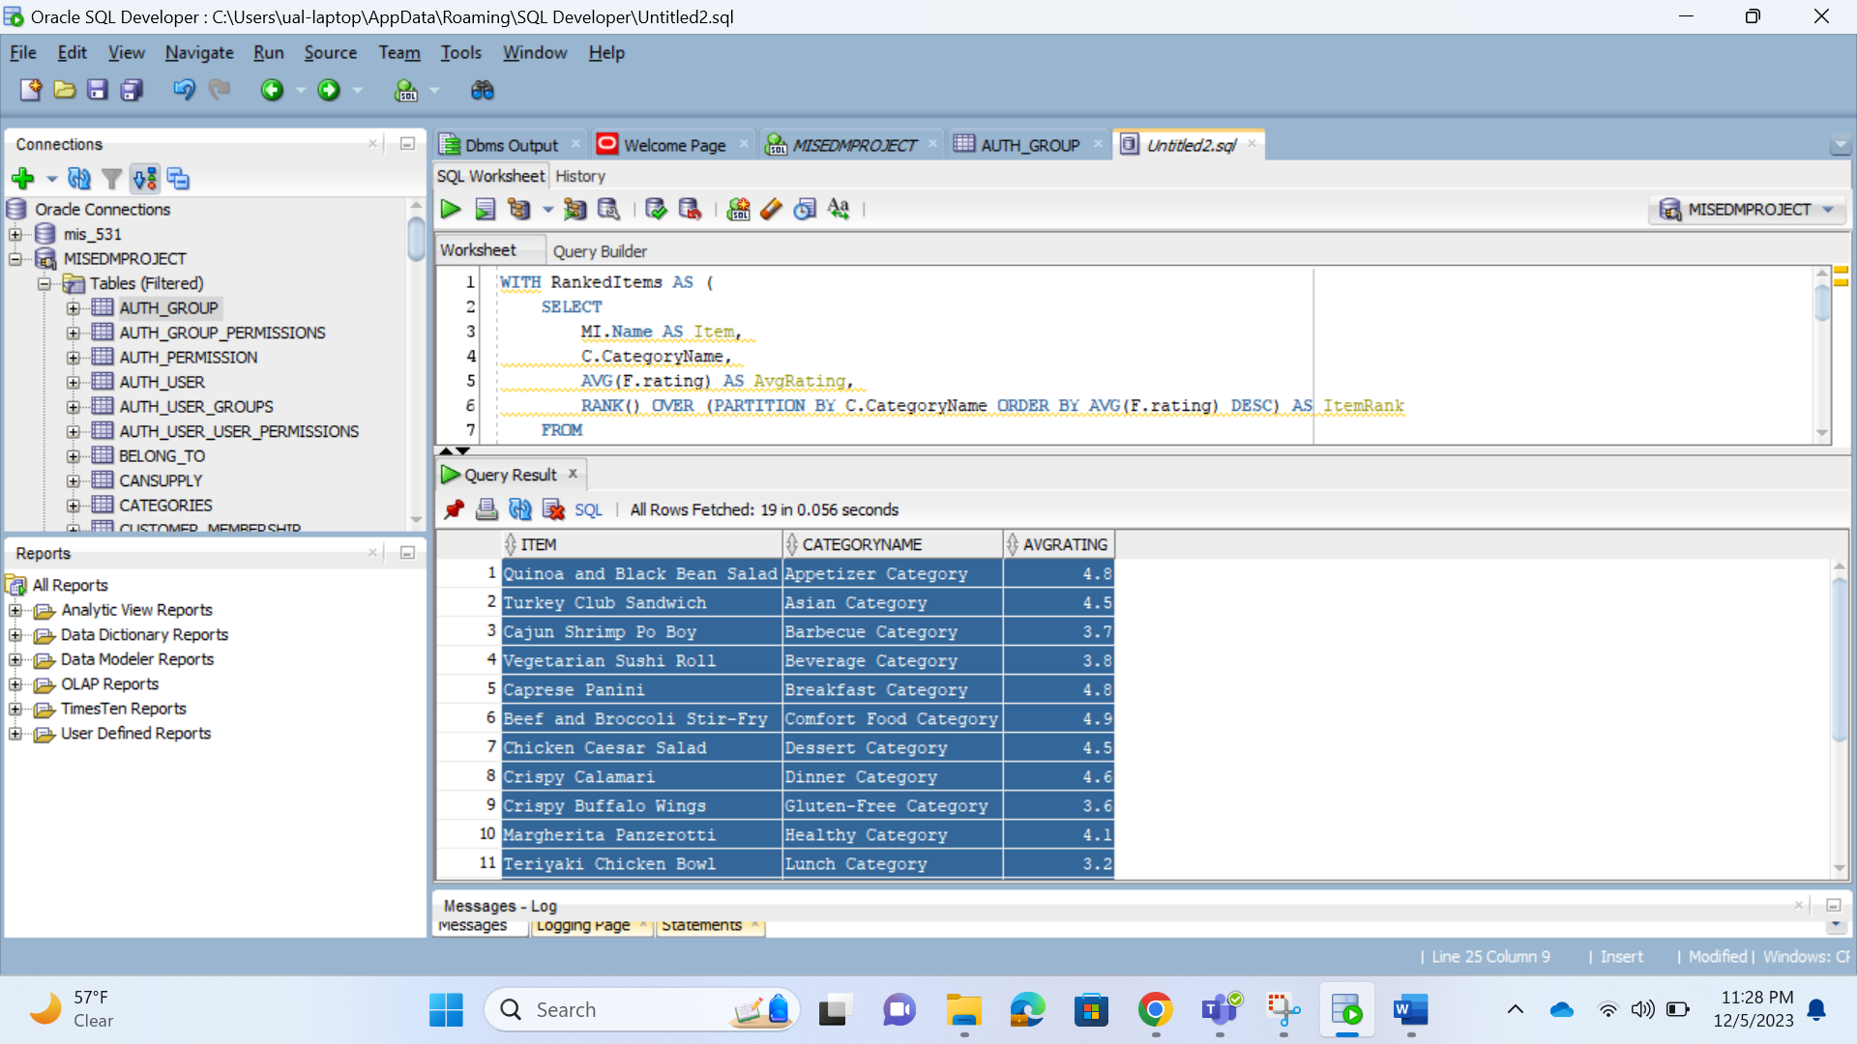

Explanation:

* The query aims to find the highest-rated item in each category based on customer feedback.
* It uses a CTE (RankedItems) to calculate the average rating and rank for each item within its category.
* The main query then filters the results to include only items with a rank of 1 (the highest rating) within each category.
* The final result includes the item name, category name, and average rating, ordered by category.

Query 2: Breakdown of the total amount for each payment method, along with subtotals for each distinct payment method and a grand total.

WITH PaymentRanking AS (

SELECT

paymentmethod,

SUM(totalamount) AS TotalAmount,

RANK() OVER (ORDER BY SUM(totalamount) DESC) AS PaymentRank

FROM payments p

JOIN order_payment op ON p.paymentid = op.paymentid

JOIN orders o ON op.orderid = o.orderid

GROUP BY paymentmethod

)

SELECT

COALESCE(paymentmethod, 'Total') AS PaymentMethod,

SUM(TotalAmount) AS TotalAmount,

MAX(PaymentRank) AS PaymentRank

FROM PaymentRanking

GROUP BY ROLLUP(paymentmethod)

ORDER BY PaymentRank;

Output:

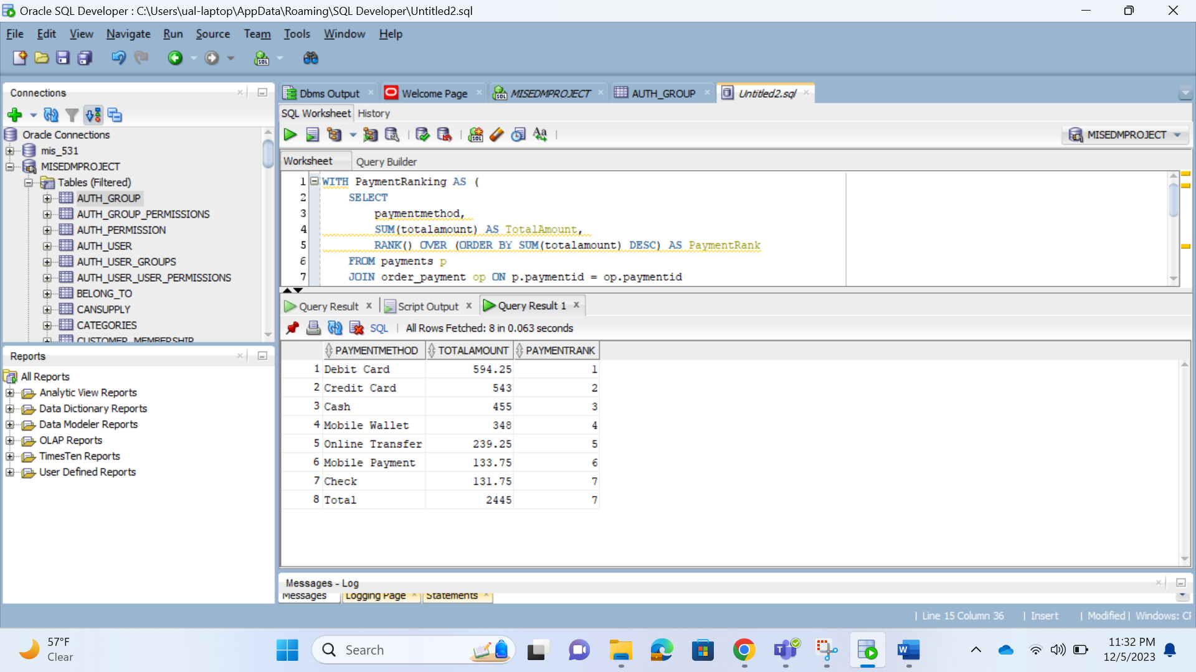

Explanation:

* The query aims to provide a breakdown of the total amount for each payment method, along with subtotals for each distinct payment method and a grand total.
* It uses a CTE (PaymentRanking) to calculate the total amount and rank for each distinct payment method based on orders and payments.
* The main query then uses the COALESCE function to replace NULL values in the paymentmethod column with 'Total'.
* The ROLLUP grouping set is used to calculate subtotals and the grand total.
* The final result includes the payment method, total amount, and payment rank for each grouping, ordered by payment rank.

Query 3: Top supplier for each ingredient

SELECT ingredientName, Name, SupplierRank

FROM (

SELECT

ingredientName,

Name,

RANK() OVER (PARTITION BY ingredientName ORDER BY Frequency DESC) AS SupplierRank

FROM (

SELECT

I.ingredientName,

S.Name,

COUNT(*) AS Frequency

FROM CANSUPPLY CS

JOIN INGREDIENTS I ON CS.ingredientID = I.ingredientID

JOIN SUPPLIERS S ON CS.SupplierID = S.SupplierID

GROUP BY I.ingredientName, S.Name

)

) ranked_data

WHERE SupplierRank <= 1;

Output:

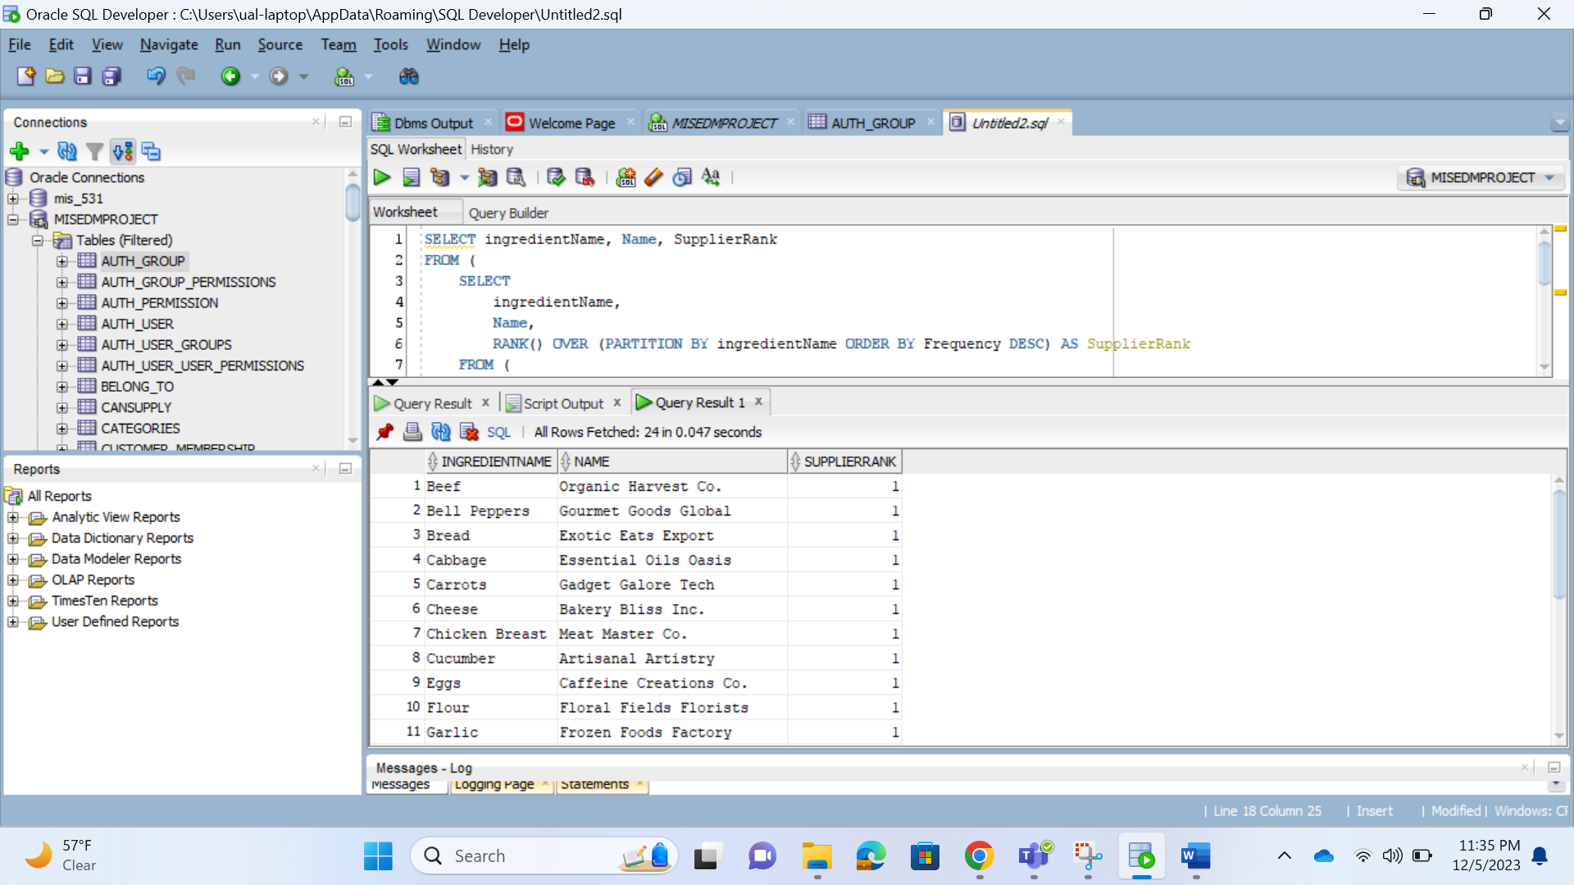

Explanation:

* The query aims to find the top supplier for each ingredient based on the frequency of occurrences in the CANSUPPLY table.
* The innermost query retrieves the count of occurrences for each combination of ingredient and supplier.
* The ranked data subquery calculates the rank of each supplier for each ingredient based on the frequency.
* The main query selects the ingredient name, supplier name, and supplier rank, filtering to include only the top supplier for each ingredient.

Query 4: For each category of jobTitle display salary statistics.

WITH SalaryAnalysis AS (

SELECT

position,

AVG(salary) AS AverageSalary,

MAX(salary) AS MaxSalary,

MIN(salary) AS MinSalary,

COUNT(*) AS EmployeeCount,

RANK() OVER (ORDER BY AVG(salary) DESC) AS SalaryRank

FROM

employees e

JOIN

works_at wa ON e.employeeid = wa.employeeid

WHERE

locationid = 4001

GROUP BY

position

)

SELECT

position,

AverageSalary,

MaxSalary,

MinSalary,

EmployeeCount,

SalaryRank

FROM

SalaryAnalysis

ORDER BY

SalaryRank;

Output:

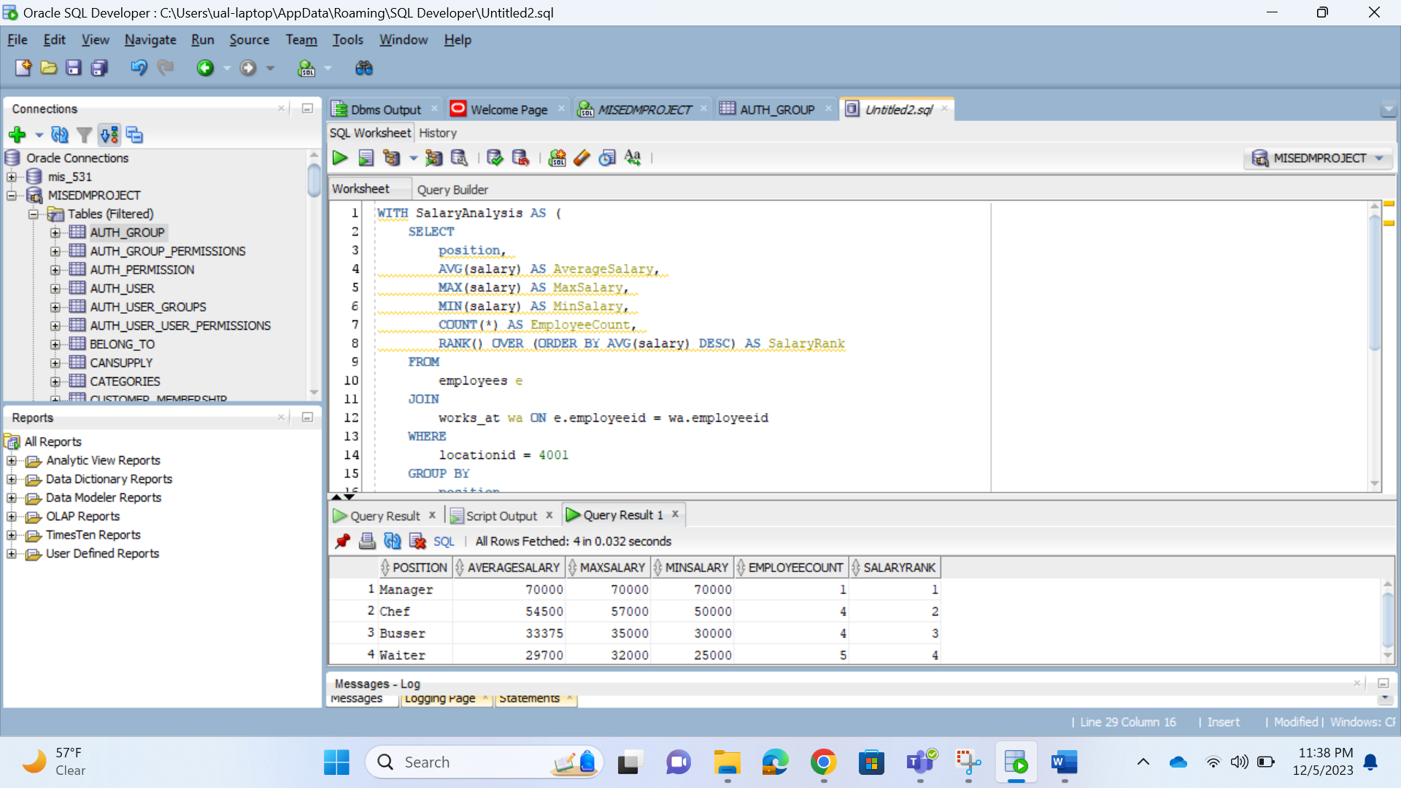

Explanation:

* The query aims to display salary statistics for each category of job title (position).
* The CTE (SalaryAnalysis) calculates average, maximum, and minimum salaries, along with the employee count for each job position at a specific location.
* The main query selects the relevant columns from the CTE and orders the result by the salary rank.

Query 5: Provide info on promotions by calculating the average order value (rounded to two decimal places) and the number of orders for each promotion.

SELECT

P.promotionName,

ROUND(AVG(O.TotalAmount), 2) AS AverageOrderValue,

COUNT(O.OrderID) AS NumberOfOrders

FROM

PROMOTIONS P

JOIN

PROMOTION_ORDERDETAILS POD ON P.promotionID = POD.promotionID

JOIN

ORDERS O ON POD.OrderID = O.OrderID

GROUP BY

P.promotionName

ORDER BY

AverageOrderValue DESC;

Output:

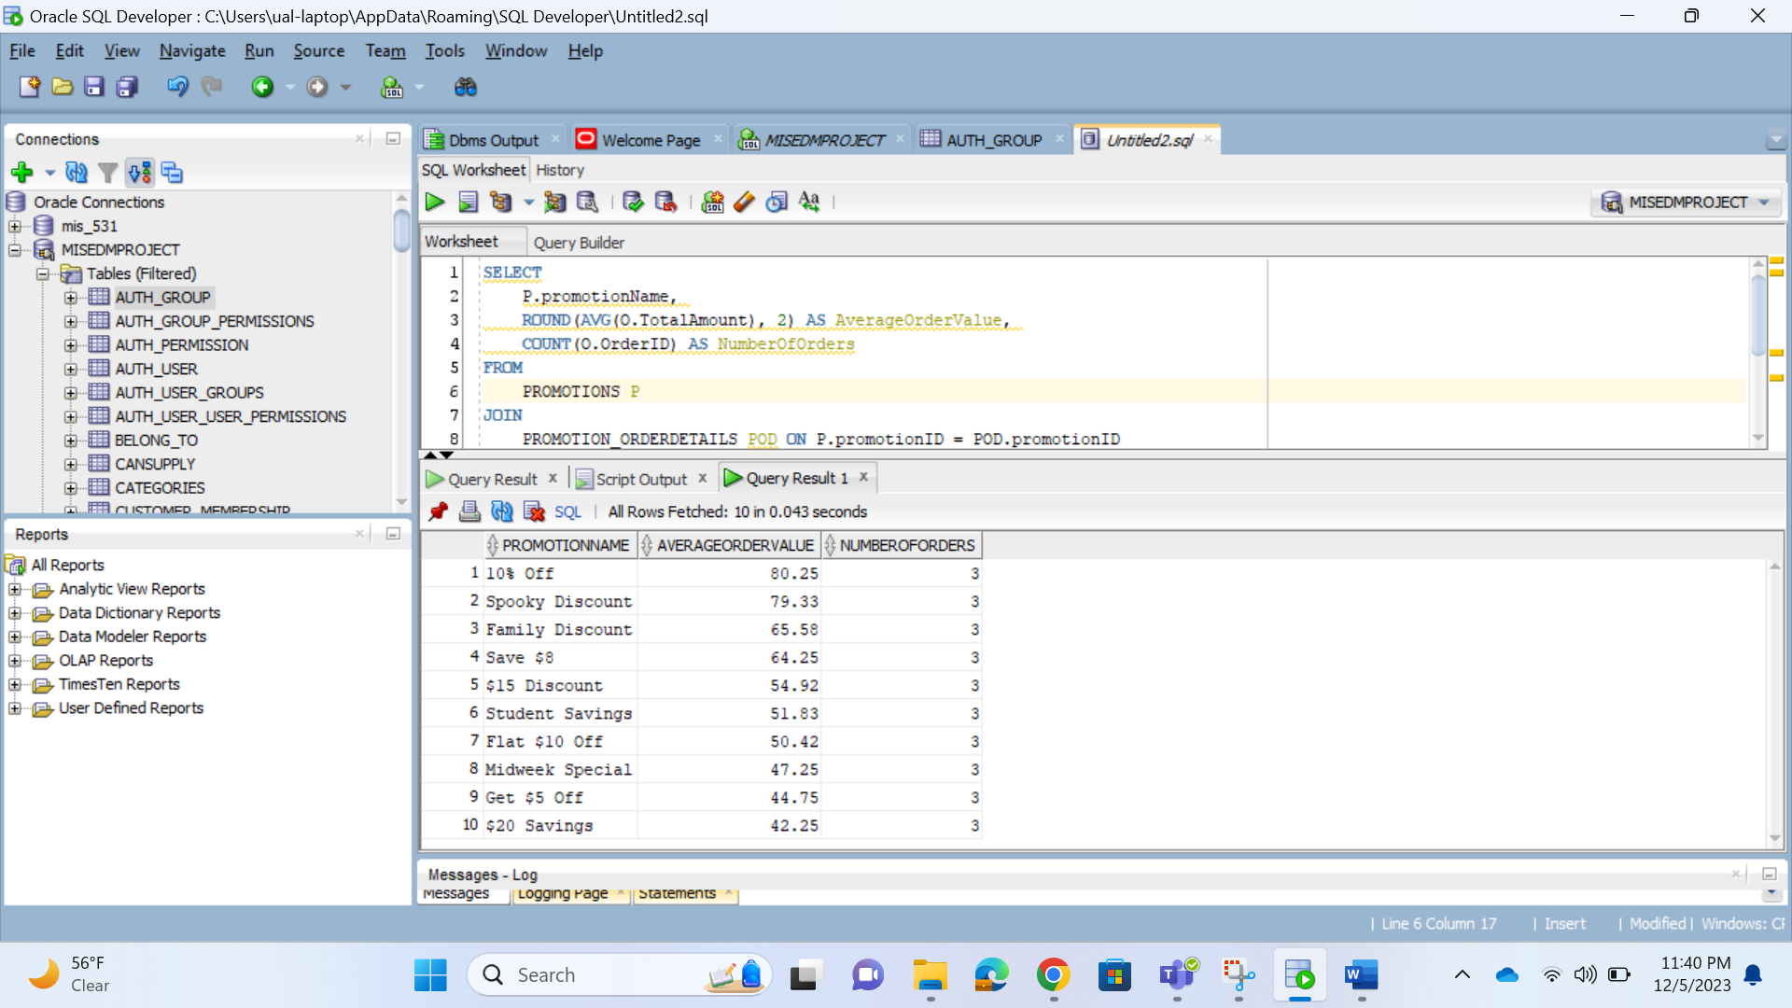

Explanation:

* The query calculates the average order value and counts the number of orders for each promotion.
* It retrieves the promotion name, the rounded average order value, and the number of orders for each promotion.
* The results are grouped by promotion name and ordered in descending order based on the average order value.

Query 6: Summary of deliveries based on the day of the week, including the number of deliveries and the total value of orders for each day.

WITH DeliverySummary AS (

SELECT

TRIM(TO_CHAR(D.DeliveryDate, 'Day')) AS Weekday,

COUNT(D.DeliveryID) AS NumberOfDeliveries,

SUM(O.TotalAmount) AS TotalValueOfOrders

FROM

DELIVERY D

JOIN

DELIVERY_ORDERDETAILS DO ON D.DeliveryID = DO.DeliveryID

JOIN

ORDERS O ON DO.OrderID = O.OrderID

GROUP BY

TRIM(TO_CHAR(D.DeliveryDate, 'Day'))

)

SELECT

Weekday,

NumberOfDeliveries,

TotalValueOfOrders

FROM

DeliverySummary

ORDER BY

CASE Weekday

WHEN 'Monday' THEN 1

WHEN 'Tuesday' THEN 2

WHEN 'Wednesday' THEN 3

WHEN 'Thursday' THEN 4

WHEN 'Friday' THEN 5

WHEN 'Saturday' THEN 6

WHEN 'Sunday' THEN 7

END;

Output:

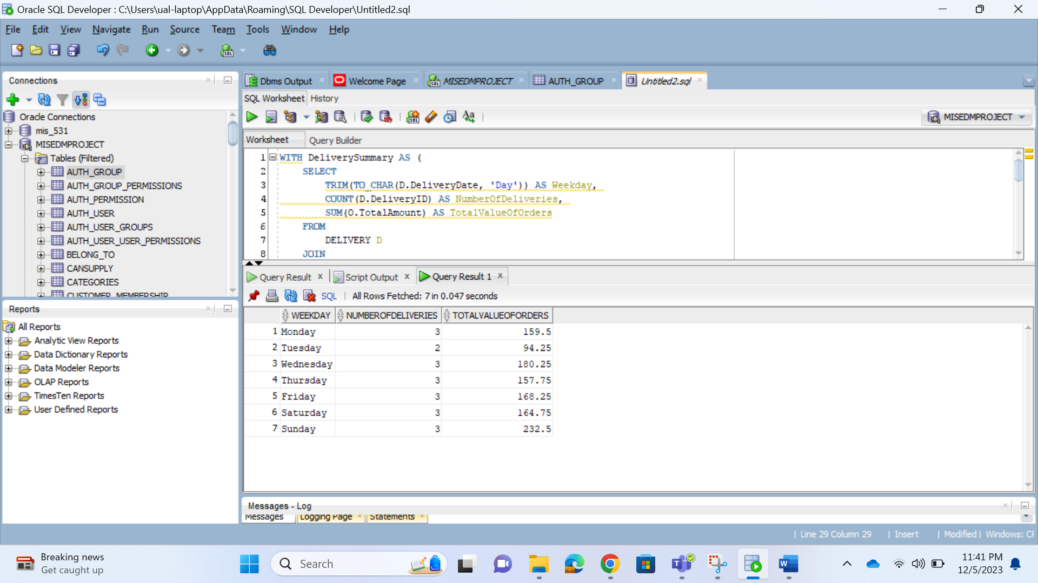

Explanation:

* The query aims to provide a summary of deliveries based on the day of the week.
* The CTE (DeliverySummary) calculates the number of deliveries and the total value of orders for each day of the week.
* The main query selects the weekday, number of deliveries, and total value of orders from the CTE.
* The results are ordered based on the specified order of weekdays.

Query 7: Summary of deliveries based on the day of the week, including the number of deliveries and the total value of orders for each day.

SELECT

CASE

WHEN mi.Price < 10 THEN 'Affordable'

WHEN mi.Price >= 10 AND mi.Price <= 14 THEN 'Medium'

WHEN mi.Price > 14 THEN 'Expensive'

END AS PriceCategory,

COUNT(DISTINCT od.ItemID) AS NumberOfItems,

SUM(od.Quantity) AS TotalItemsSold,

SUM(od.Quantity * mi.Price) AS TotalSaleAmount

FROM

order_details od

JOIN

menu_items mi ON od.ItemID = mi.ItemID

GROUP BY

CASE

WHEN mi.Price < 10 THEN 'Affordable'

WHEN mi.Price >= 10 AND mi.Price <= 14 THEN 'Medium'

WHEN mi.Price > 14 THEN 'Expensive'

END;

Output:

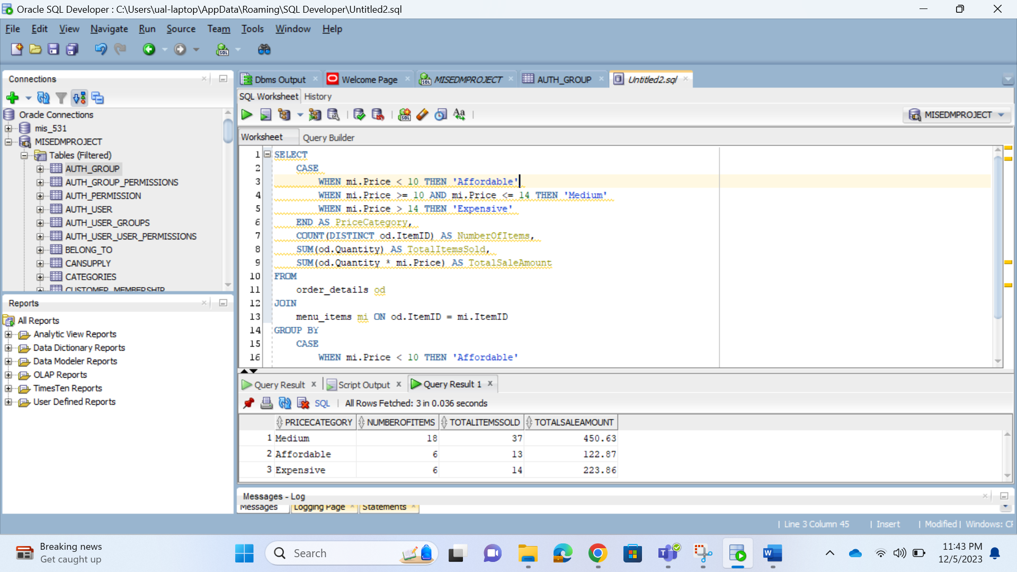

Explanation:

* The query provides a summary of sales based on different price categories for menu items.
* The CASE statement categorizes items into 'Affordable,' 'Medium,' and 'Expensive' based on their prices.
* It then calculates the number of distinct menu items sold, the total quantity of items sold, and the total sale amount for each price category.
* The results are grouped by the assigned price category, providing insights into sales performance across different price ranges.

Query 8: Most recent stocking information in each warehouse.

WITH LatestStock AS (

SELECT

w.warehouseID,

w.address AS WarehouseAddress,

hi.ingredientID,

i.ingredientName,

wd.unitsOfStocking,

wd.dateOfStocking,

ROW_NUMBER() OVER (PARTITION BY w.warehouseID, hi.ingredientID ORDER BY wd.dateOfStocking DESC) AS StockingRank

FROM

WAREHOUSE w

JOIN

WAREHOUSE_DETAILS wd ON w.warehouseID = wd.warehouseID

JOIN

STORED_IN si ON wd.warehouseID = si.warehouseID

JOIN

HAS_INGREDIENTS hi ON si.ingredientID = hi.ingredientID

JOIN

INGREDIENTS i ON hi.ingredientID = i.ingredientID

)

SELECT

warehouseID,

WarehouseAddress,

ingredientID,

ingredientName,

unitsOfStocking,

dateOfStocking

FROM

LatestStock

WHERE

StockingRank = 1;

Output:

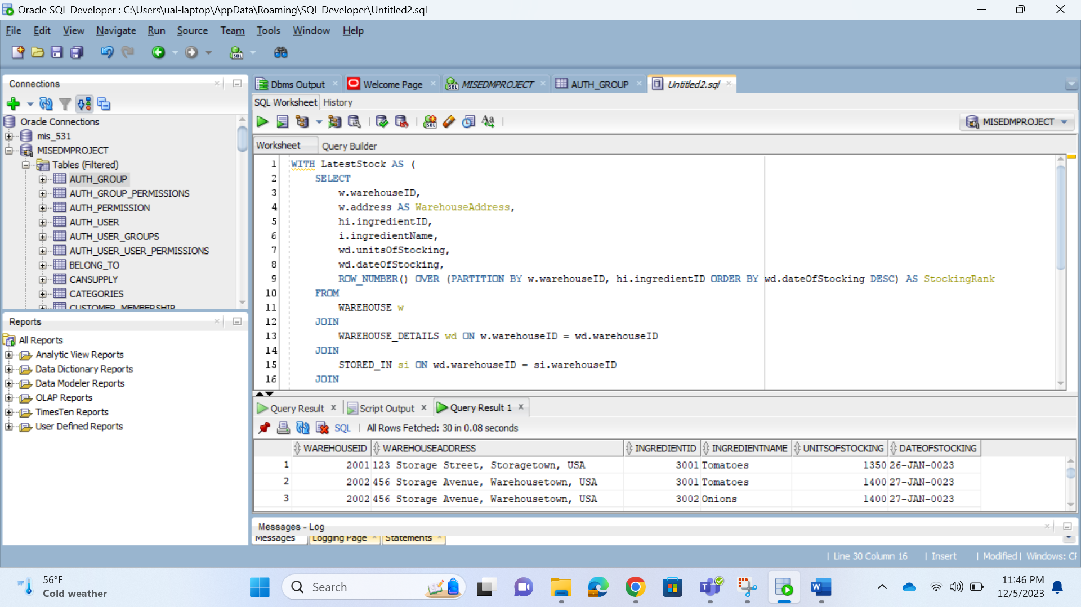

Explanation:

* The query aims to retrieve the most recent stocking information for each warehouse and ingredient combination.
* The CTE (LatestStock) uses the ROW_NUMBER() window function to assign a rank to each stocking entry within the same warehouse and ingredient partition, ordered by the descending date of stocking.
* The main query selects columns from the CTE where the StockingRank is equal to 1, ensuring that only the most recent stocking entry for each warehouse and ingredient is included in the final result.

Query 9: Cumulative sales

SELECT

o.OrderDate,

SUM(o.TotalAmount) AS DailySales,

SUM(SUM(o.TotalAmount)) OVER (ORDER BY o.OrderDate) AS CumulativeSales

FROM

ORDERS o

GROUP BY

o.OrderDate

ORDER BY

o.OrderDate;

Output:

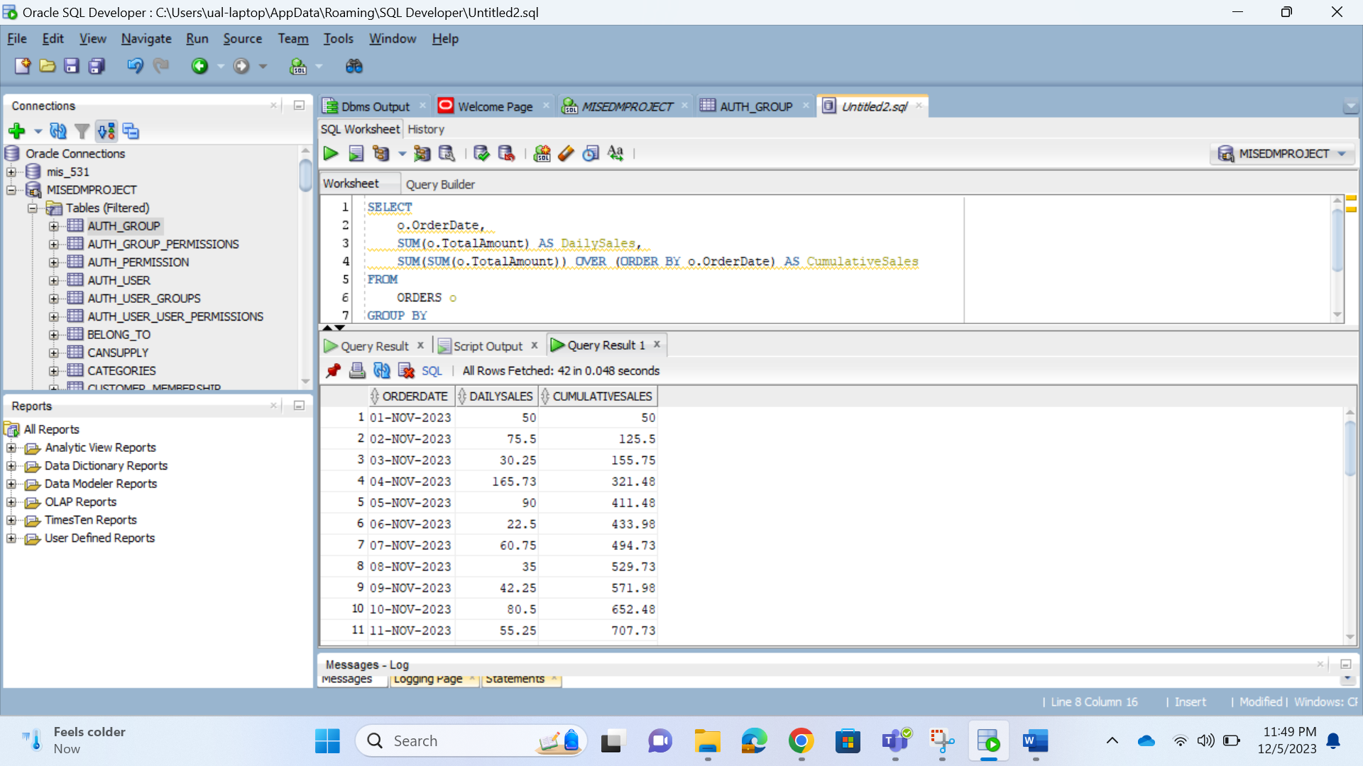

Explanation:

* The query calculates daily and cumulative sales for each order date.
* SUM(o.TotalAmount) AS DailySales calculates the total sales amount for each day.
* SUM(SUM(o.TotalAmount)) OVER (ORDER BY o.OrderDate) AS CumulativeSales uses the window function SUM() to calculate the cumulative sales. The ORDER BY clause in the window function specifies the order of summation based on the OrderDate.

Query 10: Rank the promotions based on their discount percentages in descending order.

SELECT p.promotionid, p.promotionname, p.discount, RANK() OVER (ORDER BY p.discount DESC) AS rank

FROM promotions p;

Output:

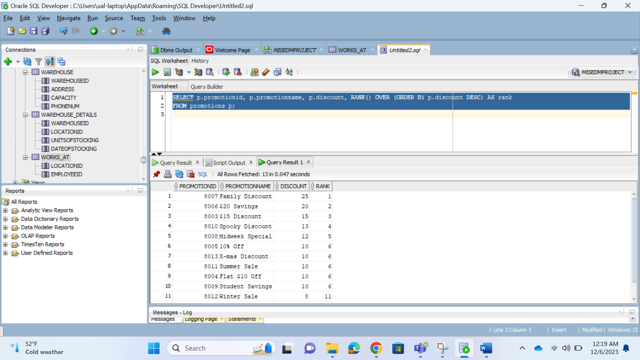

Explanation:

* The query retrieves information about promotions from the promotions table.
* It includes the promotionid, promotionname, and discount columns.
* The RANK() OVER (ORDER BY p.discount DESC) AS rank calculates the rank of each promotion based on its discount percentage in descending order.

Query 11: Top 3 Categories by the Number of Items with Ranks

SELECT

categoryname,

total_items,

RANK() OVER (ORDER BY total_items DESC) AS category_rank

FROM (

SELECT c.categoryname, COUNT(b.itemid) AS total_items

FROM categories c

LEFT JOIN belong_to b ON c.categoryid = b.categoryid

GROUP BY c.categoryname

)

WHERE ROWNUM <= 3;

Output:

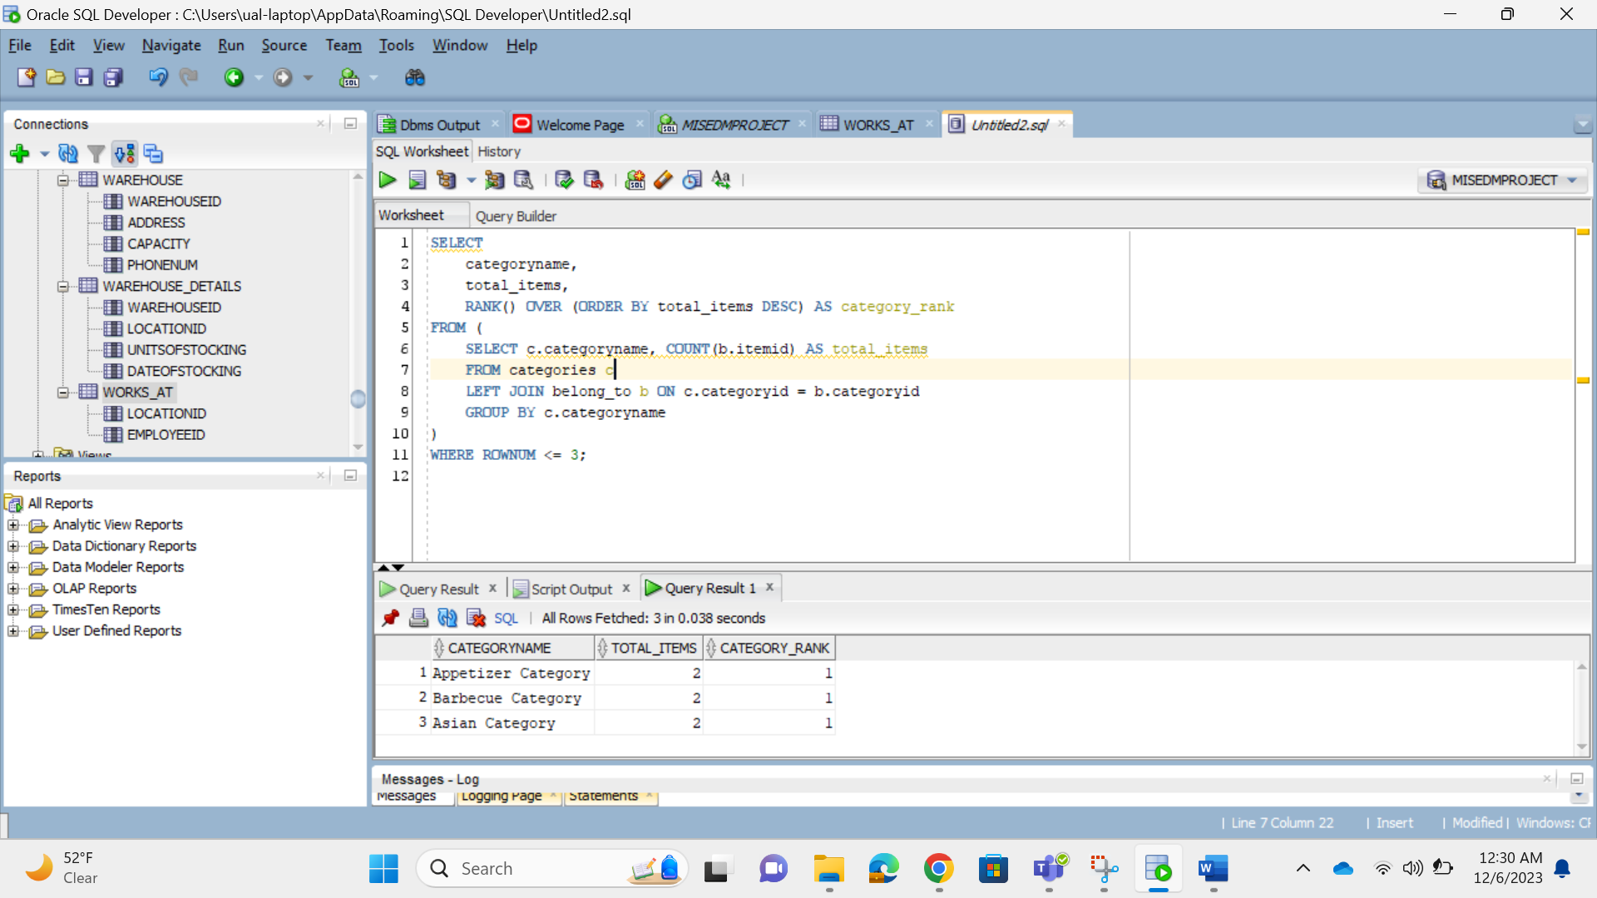

Explanation:

* The query aims to find the top 3 categories by the number of items and assign ranks to them.
* The inner query calculates the total number of items for each category using a LEFT JOIN between the categories and belong_to tables.
* The outer query then selects the category name, total items, and assigns ranks based on the total number of items in descending order.
* The WHERE ROWNUM <= 3 ensures that only the top 3 categories are included in the final result.

Query 12: Retrieve the total count of events hosted at each location, including the rank of locations by event count

SELECT l.locationid, l.locationname, COUNT(he.eventid) AS event_count,

RANK() OVER (ORDER BY COUNT(he.eventid) DESC) AS rank_by_event_count

FROM locations l

LEFT JOIN host_events he ON l.locationid = he.locationid

GROUP BY l.locationid, l.locationname

ORDER BY event_count DESC;

Output:

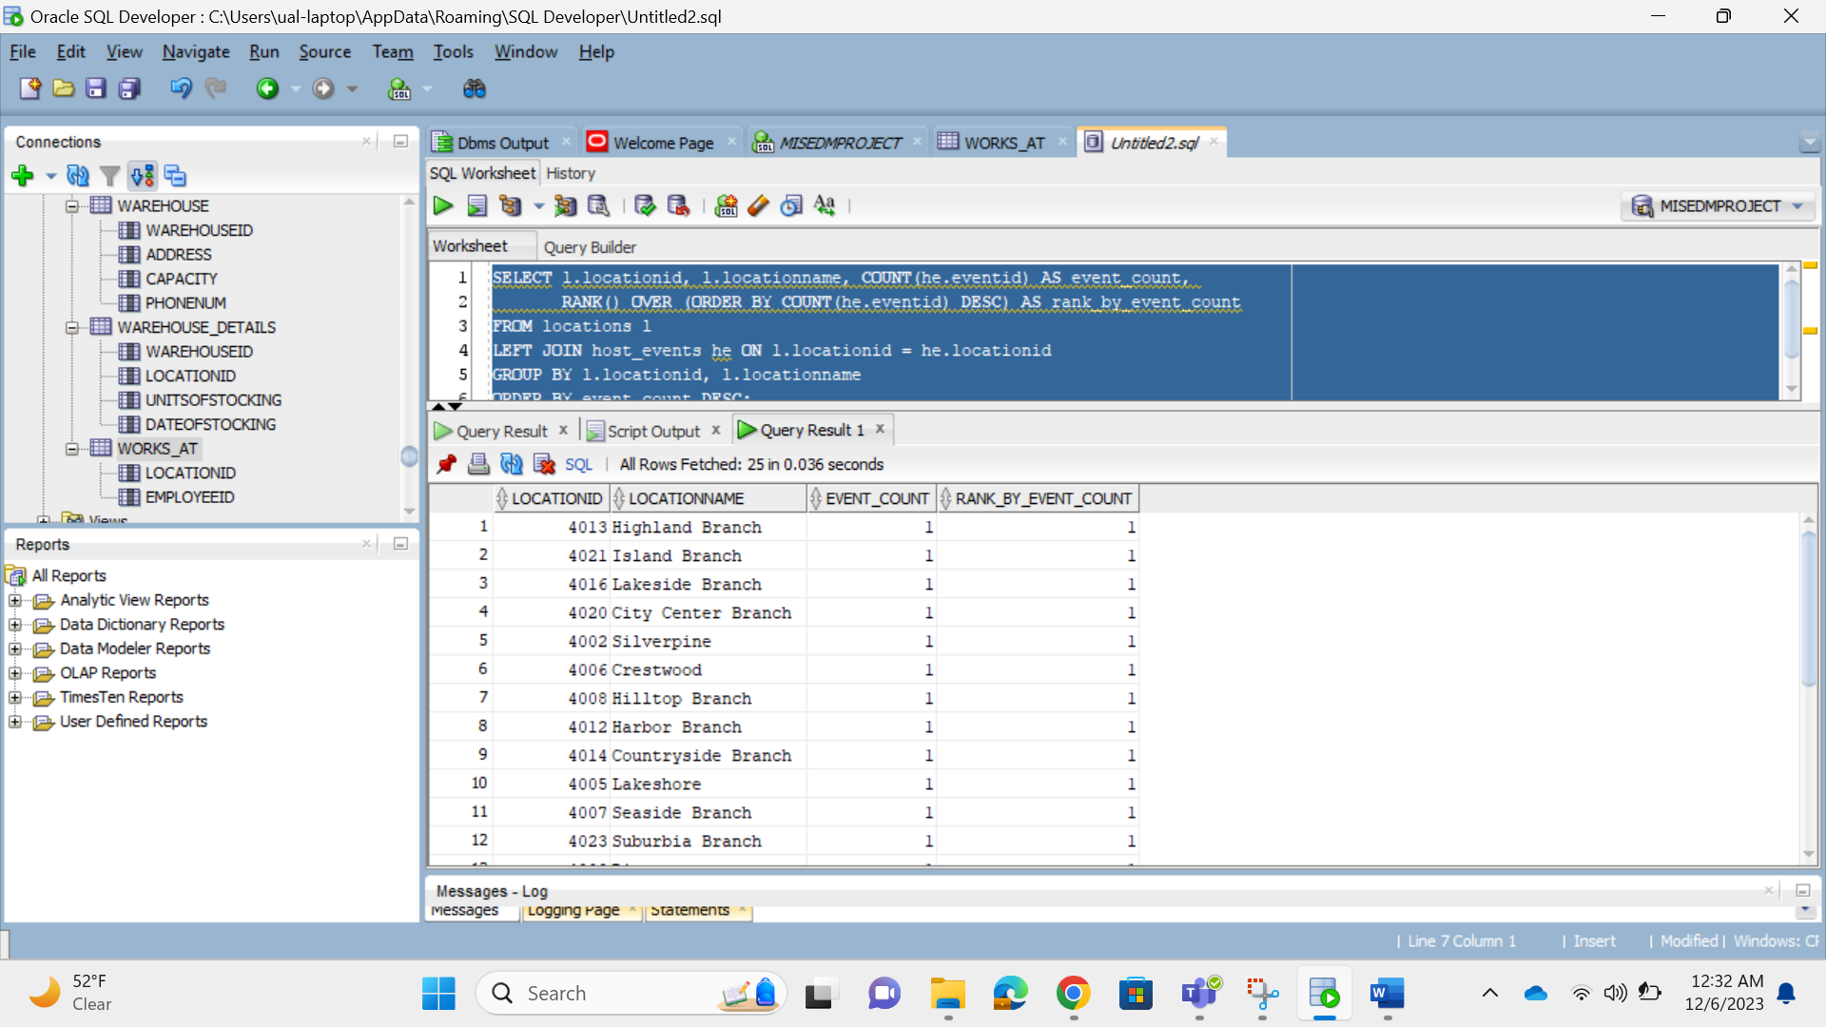

Explanation:

* The query retrieves information about the total count of events hosted at each location and assigns ranks to locations based on the event count.
* The LEFT JOIN is used to include all locations, even those with zero events.
* The GROUP BY clause groups the results by locationid and locationname to calculate the count of events for each location.
* The RANK() OVER (ORDER BY COUNT(he.eventid) DESC) calculates the rank of each location based on the count of events in descending order.
* The final result set includes columns for locationid, locationname, event_count, and the assigned rank (rank_by_event_count), ordered by the event count in descending order.

# Chapter 5:

# Triggers and Procedures

Procedure: Procedure for Calculating Total Sales by MenuItem and Updating Description

CREATE OR REPLACE PROCEDURE CalcTotalSalesByMenuItem (startDate DATE, endDate DATE)  
 IS  
 CURSOR menu_sales_cursor IS   
 SELECT mi.ItemID, mi.Name, SUM(od.Quantity) as TotalSales  
 FROM MENU_ITEMS mi  
 JOIN ORDER_DETAILS od ON mi.ItemID = od.ItemID  
 JOIN ORDERS o ON od.OrderID = o.OrderID  
 WHERE o.OrderDate BETWEEN startDate AND endDate  
 GROUP BY mi.ItemID, mi.Name;

rec menu_sales_cursor%ROWTYPE;  
 BEGIN  
 OPEN menu_sales_cursor;  
 LOOP  
 FETCH menu_sales_cursor INTO rec;  
 EXIT WHEN menu_sales_cursor%NOTFOUND;

-- Output total sales for each menu item  
 DBMS_OUTPUT.PUT_LINE('Item: ' || rec.Name || ', Total Sales: ' || rec.TotalSales);

-- Example: Update the DESCRIPTION column based on total sales  
 IF rec.TotalSales > 1000 THEN  
 UPDATE MENU_ITEMS  
 SET DESCRIPTION = 'High Sales Item'  
 WHERE ItemID = rec.ItemID;  
 ELSE  
 UPDATE MENU_ITEMS  
 SET DESCRIPTION = 'Regular Sales Item'  
 WHERE ItemID = rec.ItemID;  
 END IF;  
 END LOOP;  
 CLOSE menu_sales_cursor;  
 END CalcTotalSalesByMenuItem;

DECLARE  
 startDate DATE := TO_DATE('2023-01-01', 'YYYY-MM-DD'); -- Replace with your desired start date  
 endDate DATE := TO_DATE('2023-12-31', 'YYYY-MM-DD'); -- Replace with your desired end date  
 BEGIN  
 CalcTotalSalesByMenuItem(startDate, endDate);  
 END;  
 /

**Explanation:**

* The procedure calculates the total sales for each menu item within a specified date range and outputs the information.
* It also provides an example of updating the DESCRIPTION column of the MENU_ITEMS table based on the total sales.
* Adjust the startDate and endDate values in the DECLARE block based on your desired date range.

In natural language, the functionality of this procedure is to analyze the total sales of each menu item within a specified date range, print the results to the console, and update the description of each menu item based on its total sales. The trigger is helpful because it automates the process of analyzing and categorizing menu items based on their sales performance, providing insights into the popularity and revenue contribution of each item. This can be valuable for business decision-making, marketing strategies, and menu optimization in a restaurant or similar business context.

**Output:**

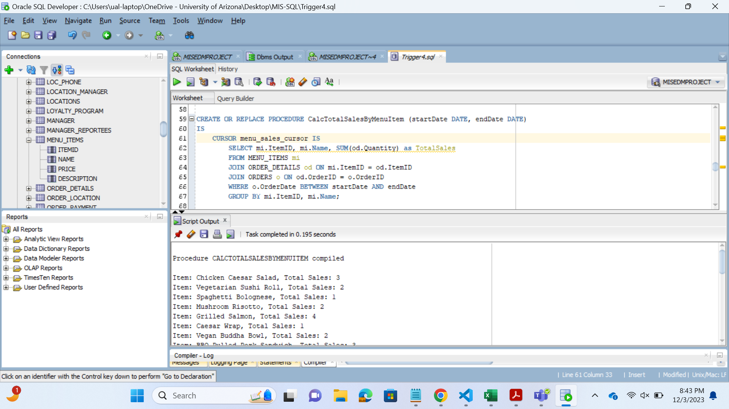

Procedure: Procedure for Retrieving Main Ingredients and Managing Ingredients Table

CREATE SEQUENCE ingredient_id_sequence START WITH 1 INCREMENT BY 1;

CREATE OR REPLACE PROCEDURE main_ingredients_of_order (order_id ORDERS.OrderID%TYPE)  
 IS  
 CURSOR ingredient_cursor IS   
 SELECT ingredientName   
 FROM INGREDIENTS   
 JOIN HAS_INGREDIENTS ON INGREDIENTS.ingredientID = HAS_INGREDIENTS.ingredientID  
 JOIN ORDER_DETAILS ON HAS_INGREDIENTS.ItemID = ORDER_DETAILS.ItemID  
 WHERE ORDER_DETAILS.OrderID = order_id;

ingredient_name INGREDIENTS.ingredientName%TYPE;  
 BEGIN  
 OPEN ingredient_cursor;  
 LOOP  
 FETCH ingredient_cursor INTO ingredient_name;  
 EXIT WHEN ingredient_cursor%NOTFOUND;

-- Existing functionality to display main ingredients  
 DBMS_OUTPUT.PUT_LINE('The main ingredient for order ID ' || order_id || ' is ' || ingredient_name);

-- Insert a new main ingredient (modify as per your table structure)  
 INSERT INTO INGREDIENTS (ingredientID, ingredientName)   
 VALUES (ingredient_id_sequence.NEXTVAL, 'New Ingredient');

-- Update an existing main ingredient (modify as per your table structure)  
 UPDATE INGREDIENTS  
 SET ingredientName = 'Updated Ingredient'  
 WHERE ingredientID = 1; -- Modify with an actual ingredient ID

-- Delete an existing main ingredient (modify as per your table structure)  
 DELETE FROM INGREDIENTS  
 WHERE ingredientID = 2; -- Modify with an actual ingredient ID  
 END LOOP;  
 CLOSE ingredient_cursor;  
 END;

DECLARE  
 order_id ORDERS.OrderID%TYPE := '802';  
 BEGIN  
 main_ingredients_for_order(order_id);  
 END;  
 /

**Explanation:**

The provided code defines an Oracle PL/SQL stored procedure named main_ingredients_of_order. The purpose of this procedure is to retrieve and display the main ingredients for a specified order, and simultaneously, it demonstrates the insertion of a new main ingredient, updating an existing main ingredient, and deleting an existing main ingredient from the INGREDIENTS table. The procedure utilizes a cursor to fetch main ingredients associated with a given order ID.

The functionality of this procedure is to display the main ingredients associated with a given order ID. Additionally, it showcases the ability to perform various operations on the INGREDIENTS table, such as inserting a new main ingredient, updating an existing main ingredient, and deleting an existing main ingredient. This procedure is helpful for managing and updating main ingredients in the context of orders, providing flexibility for menu adjustments or ingredient modifications based on business needs. It allows for dynamic and real-time changes to the main ingredients associated with specific orders.

**Output:**

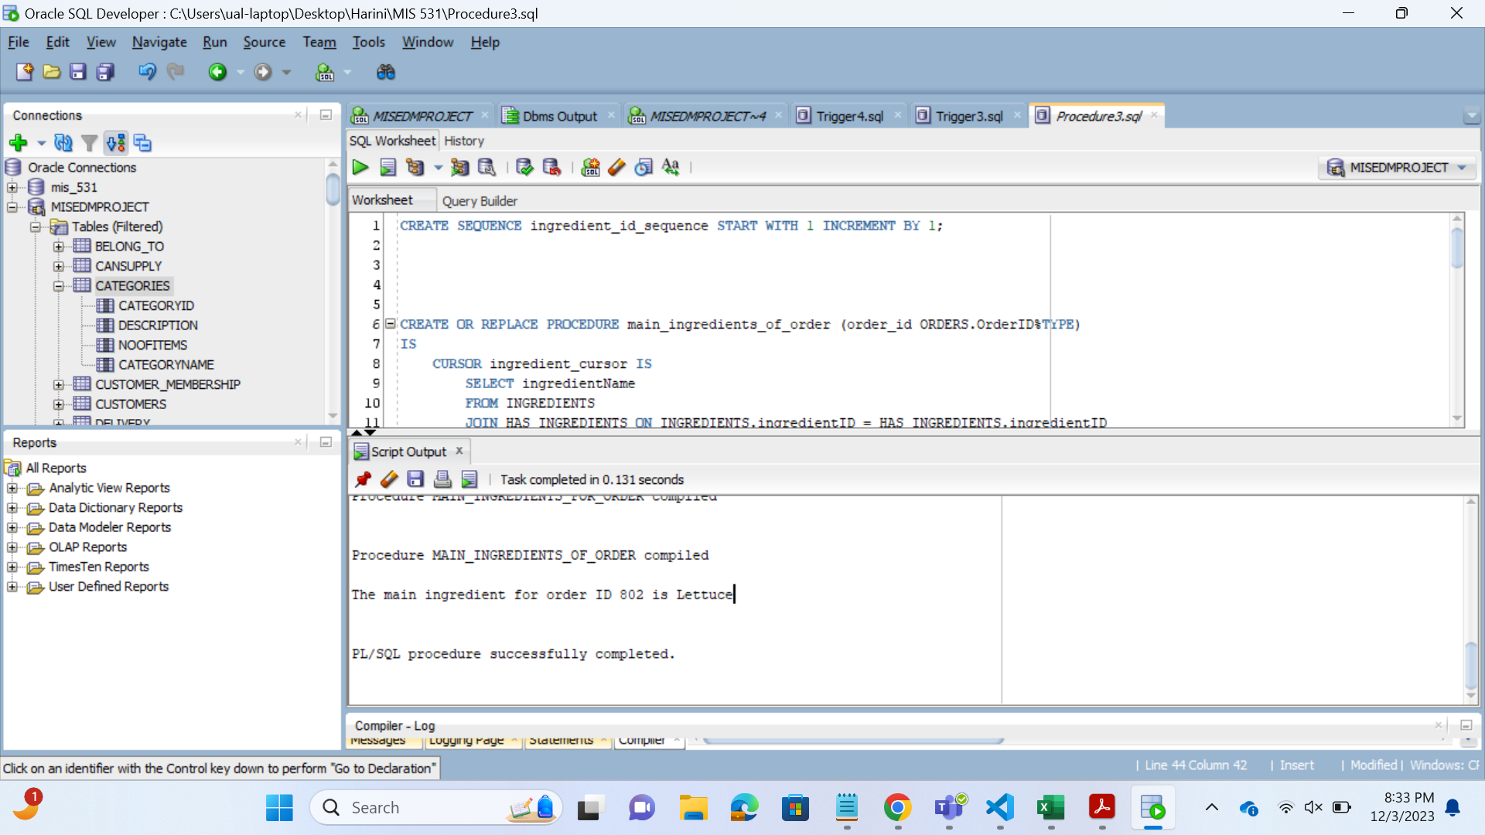

Trigger: Automated Category Item Count Maintenance Trigger

CREATE OR REPLACE TRIGGER update_category_items  
 AFTER INSERT OR DELETE ON BELONG_TO  
 FOR EACH ROW  
 BEGIN  
 IF INSERTING THEN  
 UPDATE CATEGORIES SET noOfItems = noOfItems + 1   
 WHERE CategoryID = :NEW.CategoryID;  
 ELSIF DELETING THEN  
 UPDATE CATEGORIES SET noOfItems = noOfItems - 1   
 WHERE CategoryID = :OLD.CategoryID;  
 END IF;  
 END;

-- Insert a record into BELONG_TO  
 INSERT INTO BELONG_TO (CategoryID, ItemID) VALUES (1, 6001);

-- Commit the changes  
 COMMIT;

-- Query the updated CATEGORIES table to see the changes  
 SELECT * FROM CATEGORIES WHERE CategoryID = 1;

-- Delete a record from BELONG_TO  
 DELETE FROM BELONG_TO WHERE CategoryID = 1 AND ItemID = 6001;

-- Commit the changes  
 COMMIT;

-- Query the updated CATEGORIES table to see the changes  
 SELECT * FROM CATEGORIES WHERE CategoryID = 1;

**OUTPUT**:

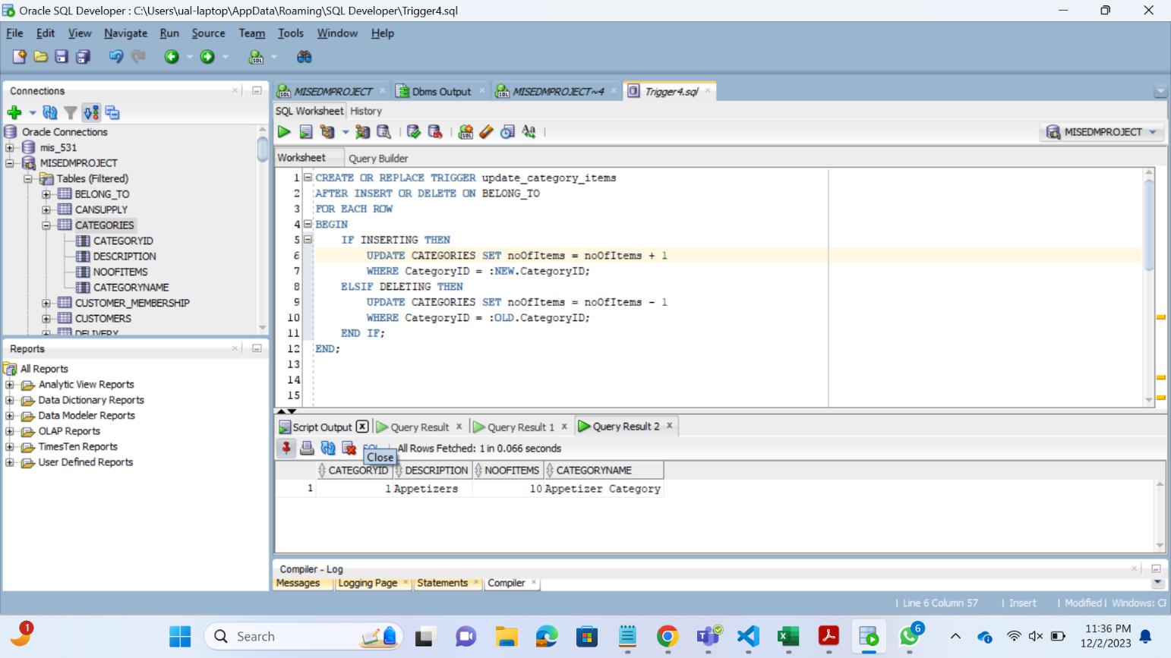

**Explanation:**

The trigger named update_category_items is designed to automatically update the noOfItems column in the CATEGORIES table whenever a new record is inserted into the BELONG_TO table or an existing record is deleted. This trigger operates for each row affected by the insert or delete operation in the BELONG_TO table. If a new record is inserted, it increments the noOfItems count for the corresponding category; if a record is deleted, it decrements the count.

**Benefits:**

* **Automated Count Maintenance:** The trigger automates the process of updating the noOfItems count in the CATEGORIES table based on changes in the BELONG_TO table. This ensures that the count remains accurate and reflects the current number of items in each category without manual intervention.
* **Consistency and Data Integrity:** By using a trigger, the update operation on the CATEGORIES table is tightly coupled with the insert and delete operations on the BELONG_TO table. This helps maintain consistency and data integrity, preventing discrepancies between the category item count and the actual records in the BELONG_TO table.

Chapter 6:

# User Interface

Link to our project: <http://ec2-35-92-168-0.us-west-2.compute.amazonaws.com:3000/>

Home page – helps nagivate to different location on the application (after logging in)

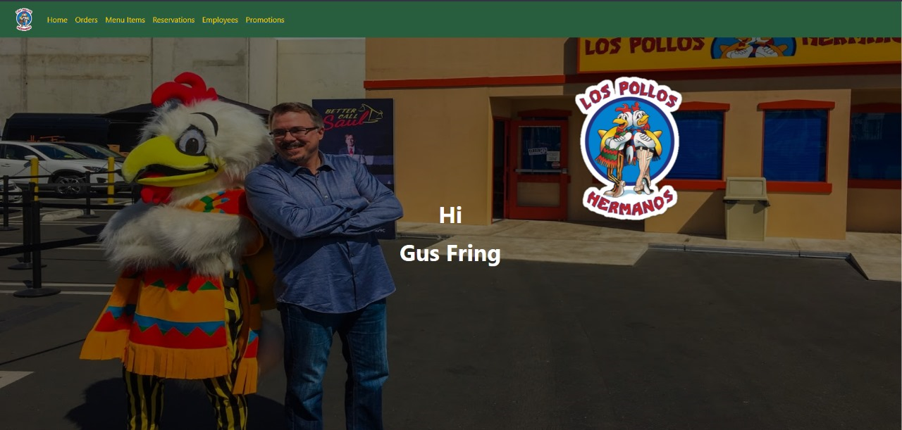

Manage various analysis such as salary, customer, and delivery summary from the home page

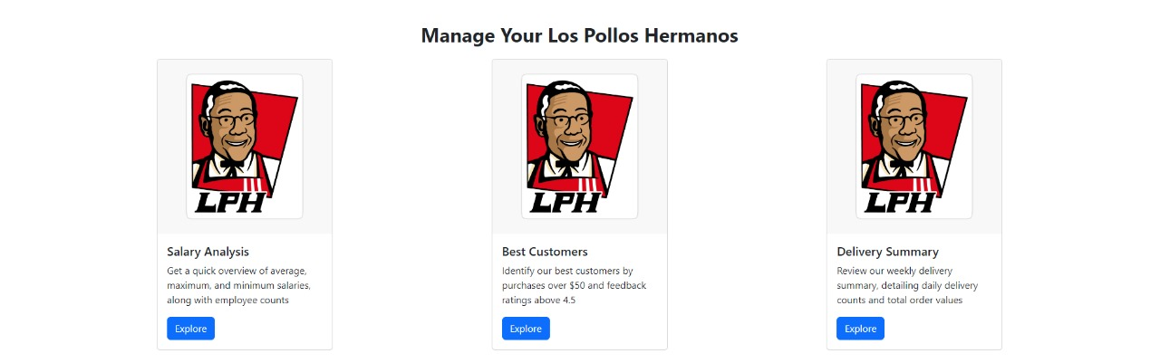

Salary analysis:

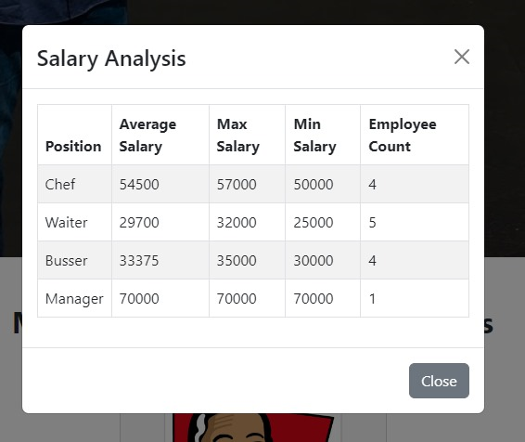

Customer analysis:

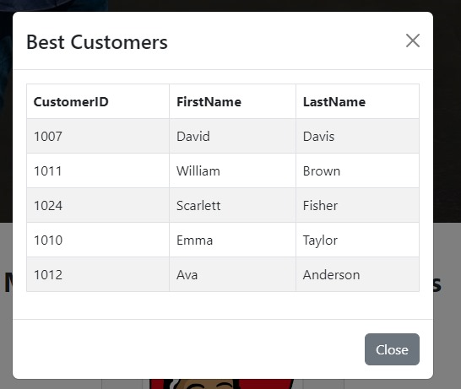

Delivery summary:

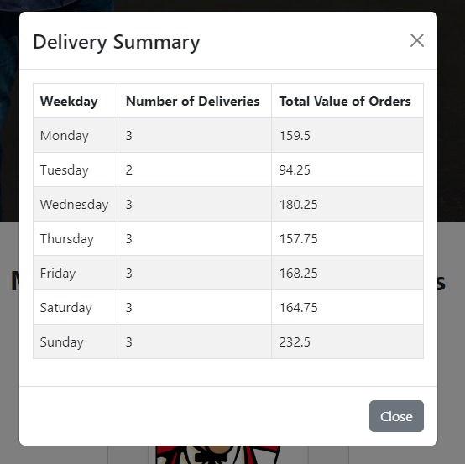

Order page – accessible from the home page. User can view the orders placed to the restaurant

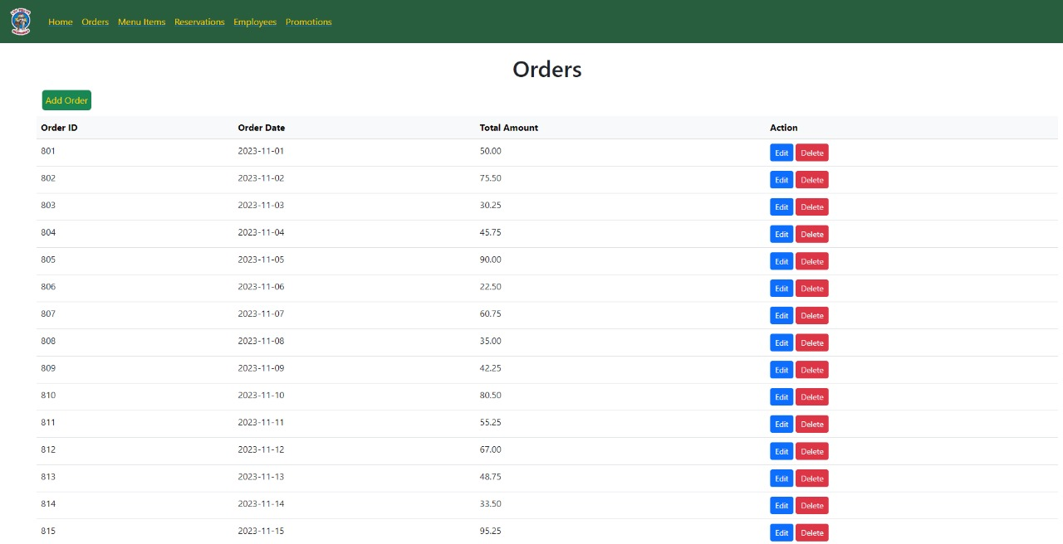

User can add a new order:

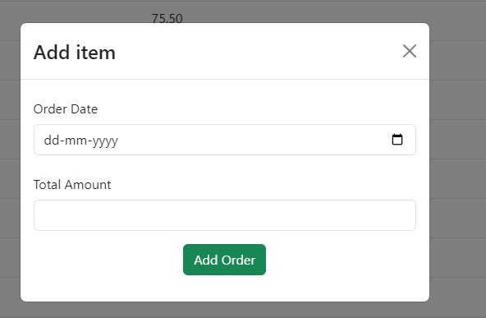

User can edit an order:

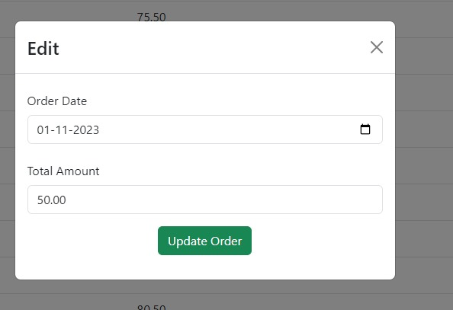

User can access reservations from home page where they can manage their reservations:

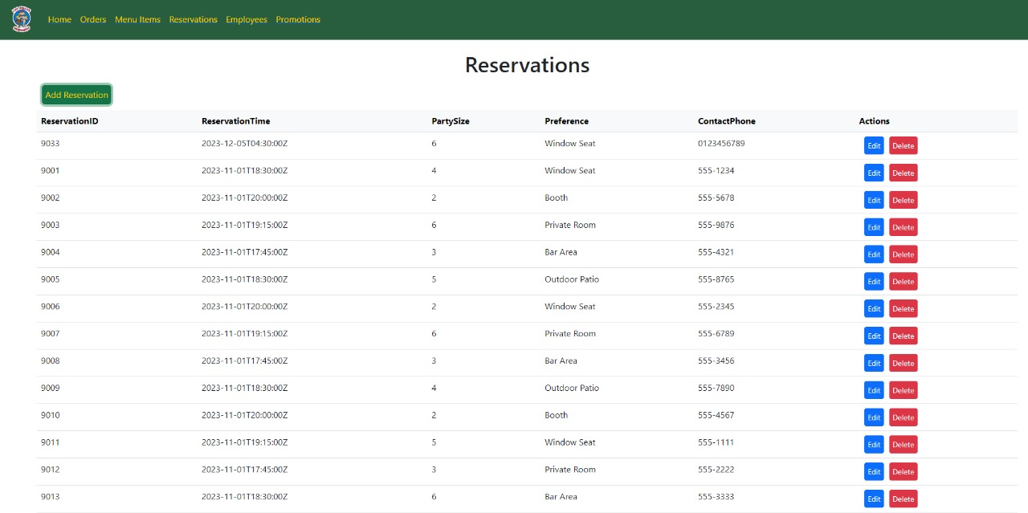

User can delete reservation:

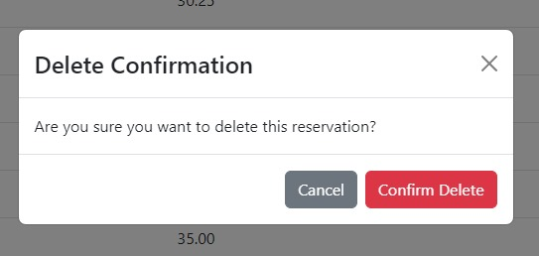

Add reservation:

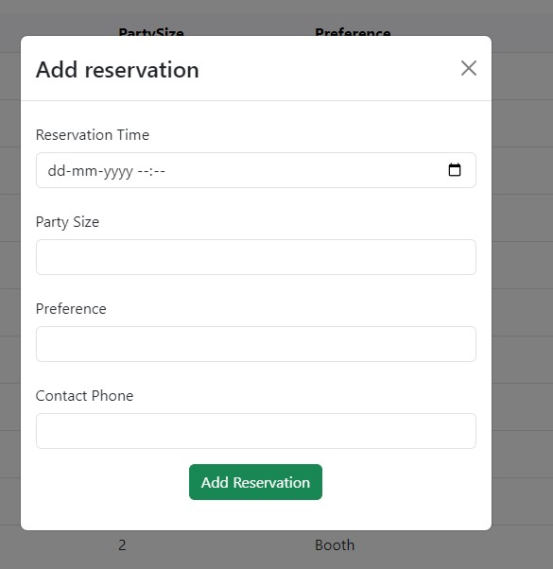

Edit reservation:

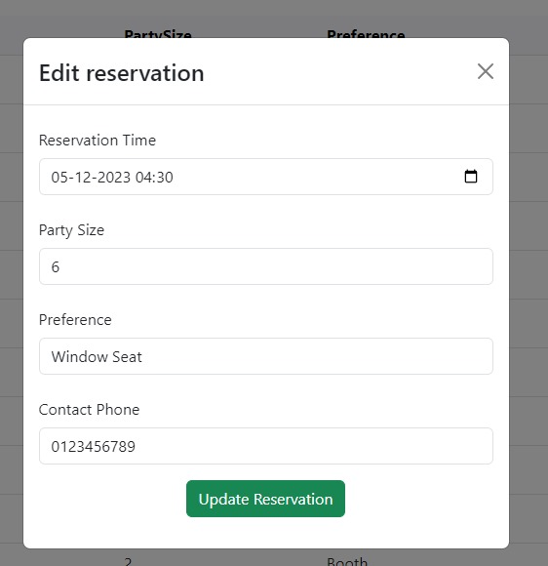

User can manage employees accessed from home page:

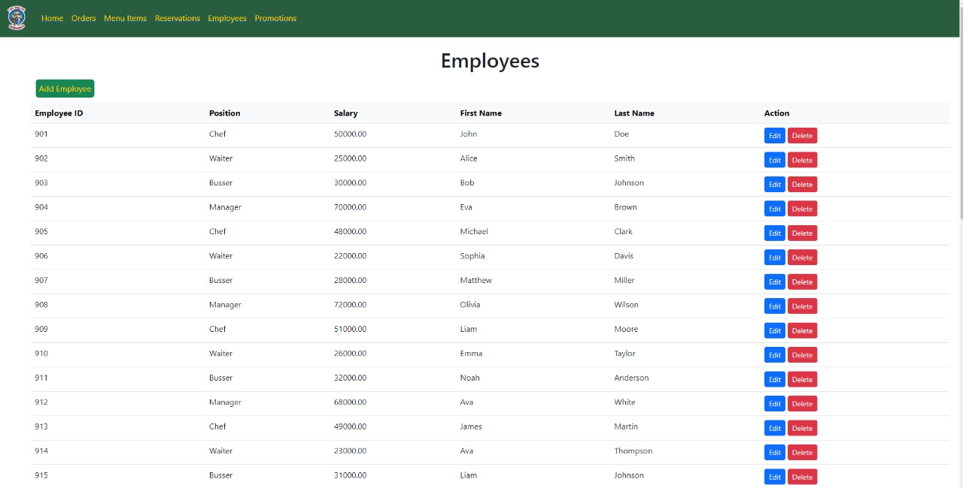

User can edit and delete employees:

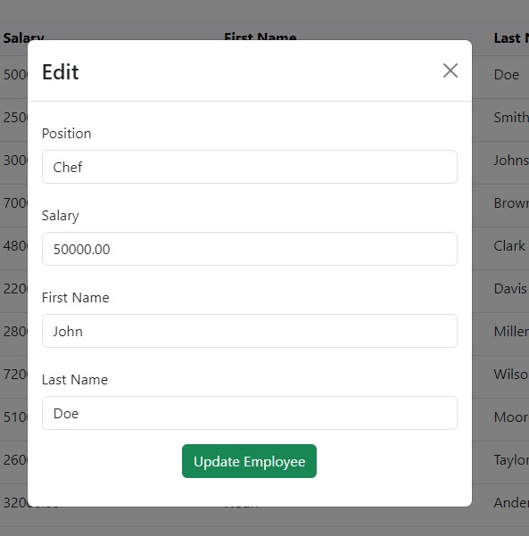

User can add employee:

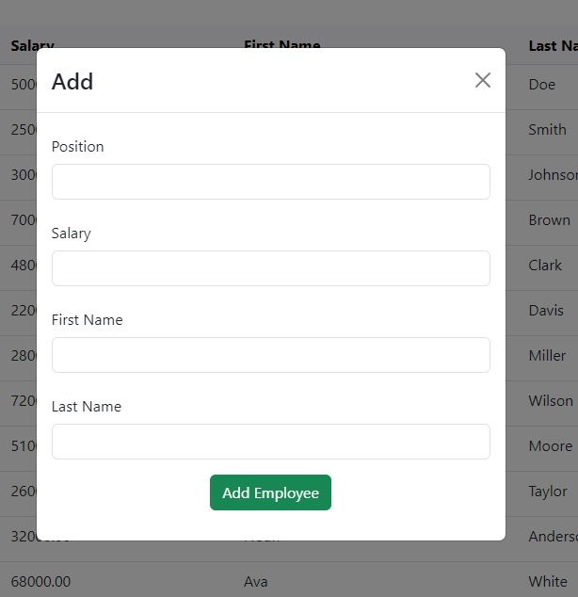

User can manage promotions:

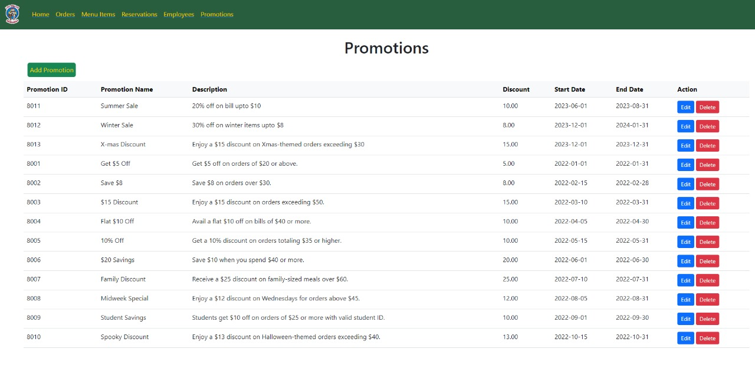

User can add the promotion applied:

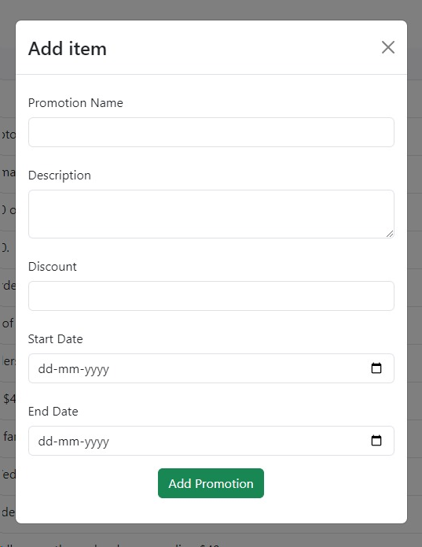

User can edit the promotion applied:

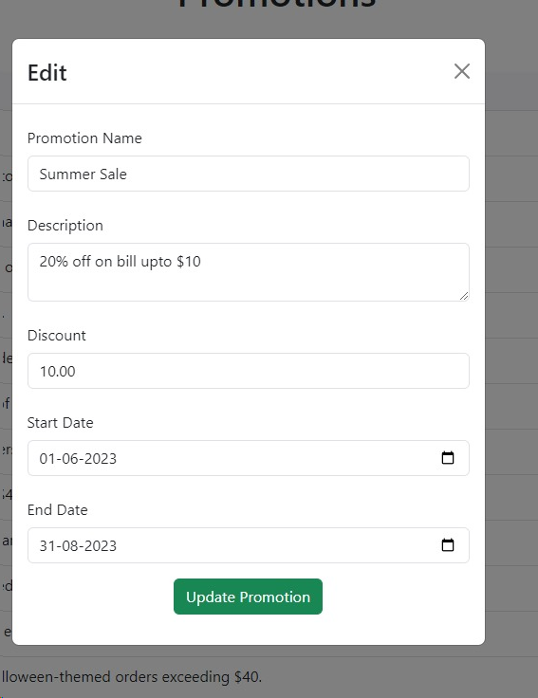

# Chapter 7:

# Implementation plan

**Project Overview:**

Develop a user interface for Los Pollos Hermanos' managers to manage operations internally. The project involves creating a database, developing a user interface, and hosting it on AWS EC2.

**Scope:**

* Database design and implementation.
* Frontend development for the user interface.
* Integration with APIs.
* Security measures for data protection.
* Testing for functionality and security.
* Deployment on AWS EC2.

**Platform:**

* Database: Oracle SQL, PostgreSQL, or similar.
* Frontend: React, Angular.
* Backend: Node.js, Python Flask/Django.
* Hosting: AWS EC2.

**Steps for Implementation:**

**1. Database Setup**

* Action Items: Create database schema, tables, and relationships based on ER diagram. Populate the database with initial data.
* Person-Hours Estimate: 80-120 hours.
* Cost Estimate:
  + Developer Salary: Approximately $40-60 per hour.

Total Cost: 7,200

* Software Licenses: Open-source database (e.g., Oracle SQL, PostgreSQL).

**2. Frontend Development**

* Action Items: Design and develop the user interface. Integrate with backend APIs.
* Person-Hours Estimate: 150-200 hours.
* Cost Estimate:
  + Developer Salary: Approximately $40-60 per hour.

**3. Security Implementation**

* Action Items: Implement authentication(OAuth 2.0), authorization, and data encryption(SHA-256).
* Person-Hours Estimate: 50-80 hours.
* Cost Estimate:
  + Security tools and software: OAuth 2.0 Implementation:
  + Development Costs: $3,000 - $15,000 (integration and customization of OAuth 2.0 in the application)
  + Third-Party Service Costs: Variable; some providers offer free tiers, while premium services can cost $100 - $1,000+ per month.

**4. Testing**

* Action Items: Functional testing, performance testing, security testing.
* Cost Estimate: Included in developer hours.

**5. Deployment**

* Action Items: Deploy application on AWS EC2. Set up monitoring and logging.
* Person-Hours Estimate: 30-50 hours.
* Cost Estimate:
  + AWS EC2 estimated costs:
    - Monthly: $6000.00
    - Yearly: $72000.00
  + Cost is estimated by 20 EC2 instances and a storage of 1000 GB
  + Total Person-Hours: 310-450 hours.

**Summary of Cost Breakdown:**

* Developer Salary: $12,400 - $27,000 (based on $40-60/hour).
* Software Licenses: Minimal (assuming open-source tools).
* Security Tools: $3,000 - $15,000 (integration and customization of OAuth 2.0 in the application).
  + AWS EC2 Hosting: Varies based on usage (use AWS Pricing Calculator for estimates).

**Appendix A: Lessons Learned**

Importance of thorough planning in database design to avoid future scalability issues.

The necessity of incorporating security measures from the beginning.

The value of iterative testing throughout development.

The benefits of clear communication and regular updates within the team.

Learning from other groups: The effectiveness of different project management methodologies, the impact of technology choices on development speed and maintenance, and the significance of user experience in interface design.

**References:**

AWS Pricing Calculator: AWS Pricing

Developer Salary Estimates: Glassdoor

Open Source Database Information: Oracle SQL, PostgreSQL